
CST2310
Information Systems Analysis and Design
Portfolio of Group Work
Ali Hassan (M00853031), Abdullahi Mohamed(M00810926), Alessio Stefano Dita(M00809761) & Shoyful Islam(M00811809)
Hendon

Abstract

In this portfolio we have documented the process of modelling an information system for a cinema. There are 5 chapters that you can go through from the Introduction, Project Management, Case Study, UML Schematic Models, and the Conclusion.

Table of Contents
Chapter 1: Introduction 5
1.1 Business Management System 5
1.2 Transaction Processing & Management Information System 5
1.3 Aims and Objectives 7
Chapter 2: Project Management 8
2.1 Project Management 8
2.2 Activity List 8
2.3 Work Breakdown Structure 11
2.4 Gantt Chart, Slack/Critical Activities and Critical Path 12
2.5 Risk Management 14
Chapter 3: Case Study 16
3.1 Narrative description 16
3.2 Business Case Statement 16
3.3 Functional Requirements 17
3.1 Non-Functional Requirements 17
3.1 Formal Methods of Primary Data Collection 18
Chapter 4: UML Schematic Models 19
4.1 UML & Each UML Individually Defined 19
4.2 Use Case Diagram and Descriptors 20
4.3 Class Diagram and Entity Relationship Diagram 22
4.4 Activity Diagrams 24
4.5 Use Sequence and Collaboration Diagrams 29
4.6 User Interface 38
Chapter 5: Conclusion 43
5.1 Link Group Work Tasks to Other Modules 43
5.2 Self Reflective Statement 43
References 45
Appendix 47

Table of Figures
Figure 1 TPS & MIS 6
Figure 2 TPS 7
Figure 3 TPS Generalization 7
Figure 4 WBS 12
Figure 5 Gantt Chart 13
Figure 6 Critical Path 14
Figure 7 Use Case 21
Figure 8 Entity Relationship Diagram 23
Figure 9 Class Diagram 23
Figure 10 Activity Diagram 1 25
Figure 11 Activity Diagram 2 26
Figure 12 Activity Diagram 3 26
Figure 13 Activity Diagram 4 27
Figure 14 Activity Diagram 5 28
Figure 15 Activity Diagram 6 29
Figure 16 Mini UCD & CLD 1 30
Figure 17 Sequence Diagram 1 30
Figure 18 Collaboration Diagram 1 31
Figure 19 Mini UCD and CLD 2 31
Figure 20 Collaboration Diagram 2 32
Figure 21 Sequence Diagram 2 32
Figure 22 Sequence Diagram 3 33
Figure 23 Mini UCD and CLD 3 33
Figure 24 Collaboration Diagram 3 34
Figure 25 Mini UCD and CLD 4 34
Figure 26 Sequence Diagram 4 35
Figure 27 Collaboration Diagram 4 35
Figure 28 Mini UCD and CLD 5 36
Figure 29 Sequence Diagram 5 36
Figure 30 Collaboration Diagram 5 37
Figure 31 Mini UCD and CLD 37
Figure 32 Sequence Diagram 6 38
Figure 33 Collaboration Diagram 6 38
Figure 34 User Interface 1 39
Figure 35 User Interface 2 40
Figure 36 User Interface 3 40
Figure 37 User Interface 4 41
Figure 38 User Interface 5 42
Figure 39 User Interface 6 42
Figure 40 User Interface 7 42
Figure 41 User Interface 8 42
Figure 42 User Interface 9 43

Chapter 1: Introduction

1.1 Business Management System
This is a system that provides vital information that organizations use to manage themselves efficiently. It includes designing diagrams, developing, and documenting. It can be applied and use of tools, techniques, and concepts of various disciplines to find solutions. Systems are built to collect, process and present data in an easier way. (Mississippi state University, 2023)
1.2 Transaction Processing & Management Information System
The Transaction Processing Systems and Management Information Systems (TPS & MIS) are the very essence of every business backstage. They both represent the daily, frequent activities that the business makes use of as well as all the data and information which are essential for the decision-making process of the business.
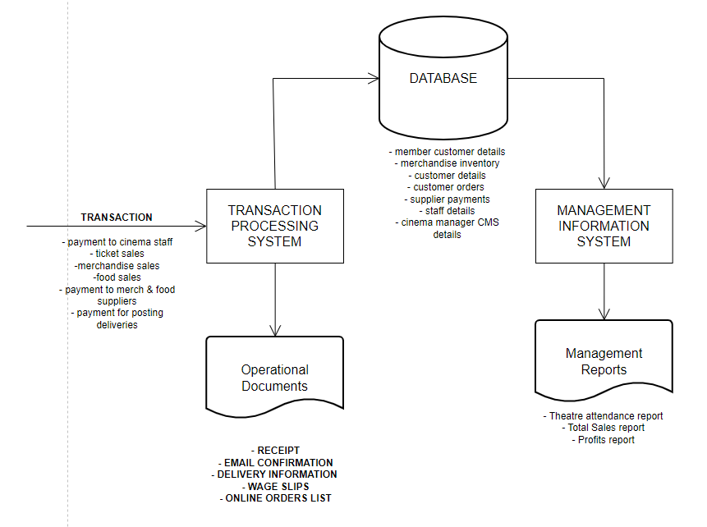
Below there is a general diagram showing how they both fit in within a business and the type of data that is used/produced by both TPS and MIS.
Figure 1 TPS & MIS
(Stair, 2021)
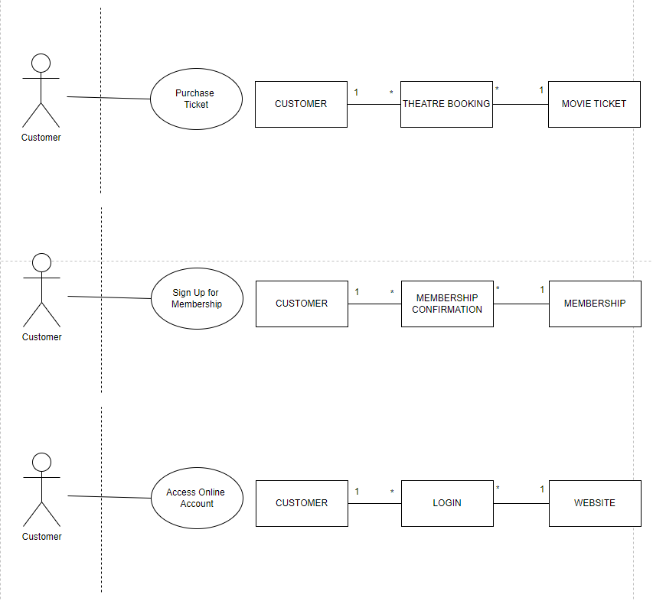
The TPS refers to the daily transactions that happen in and are essential to the business (Olivia, 2011). TPS can be for a single product/service or for multiple. Below there are examples of TPS for single transactions for our cinema:
Figure 2 TPS
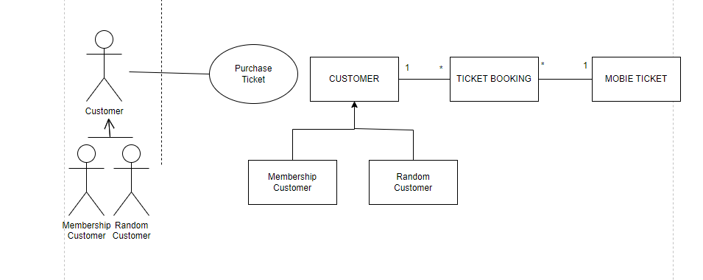
Example of a generalization of a TPS:
Figure 3 TPS Generalization

The MIS on the other hand is useful for monitoring, controlling and aiding in decision making activities. The MIS makes use of data from the TPS as well as other external sources in order to produce detailed and meaningful reports or diagrams which can then be used to analyze the business performance and make decisions accordingly Olivia (2011). For most business the MIS consists of management reports such as total revenue reports, total profit, attendance reports, staff meeting reports etc.

1.3 Aims and Objectives
The project in which this document will be based on is for a brand-new company in the entertainment and leisure domain called “Electric Cinema”. In which in the “case study” chapter of this document will go into more detail about “Electric Cinema”. This document will contain many UML schematic models in which every diagram will show the process of how “Electric Cinema” functions.

Chapter 2: Project Management

2.1 Project Management
“Project management is the application of knowledge, skills, tools and techniques to project activities to meet project requirements. Project management is accomplished through the use of process such as: initiating, planning, executing, controlling and closing.” (Project Management Institute)
“A key factor that distinguishes project management from just 'management' is that it has this final deliverable and a finite timespan, unlike management which is an ongoing process. Because of this a project professional needs a wide range of skills; often technical skills, and certainly people management skills and good business awareness.” “Project management is aimed at producing an end product that will effect some change for the benefit of the organisation that instigated the project. It is the initiation, planning and control of a range of tasks required to deliver this end product.” (APM, Association for Project Management)
Project management is used in many industries such as IT, building and construction, transport sector. Project management is also implemented on many other things in which people didn’t have a thought that they were a project manager. Such as organising an event such as a wedding, in which the person who is the project manager is managing a team to deliver the event and to have it running the way they planned. Therefore, project management is a life skill and not just implemented in the cooperate sector.
2.2 Activity List
ID | Description | Duration | Task Dependency
1.Start Project | Set tasks to each group member and ready to go | 1 day
2.Start Introduction | Everyone starting with their task | 1 day | 1
3.Define Business Information System | Clear definition and reference business information system | 1 day | 2
4.Define transactions processing | Definition of process | 1 day | 2
5.Define management information system | Reference included | 1 day | 2
6.Include operational documents | Reference included | 1 day | 2
7.Include management report | Reference included | 1 day | 2
8.The aim and objective | Information and system analysis discussed | 1 day | 2
9.Structure of introduction | Structure looked over | 1 day | 2
10.Review introduction | Re read the introduction | 1 day | 2
11.improve introduction | Add any improvement to it | 1 day | 10
12.Finalise introduction and move to new task | Prepare for next task | 1 day | 2
13.Meeting for project management | Start aligning tasks to members of group | 1 day | 12
14.Define Project Management | Reference included | 1 day | 13
15.Activity list with task dependencies | With duration and predecessor | 1 day | 13
16. Work breakdown structure | With all necessary detail | 1 day | 13
17.Gantt Chart | With an aligned graph | 1 day | 13
18.Slack/Critical activity | With all necessary detail | 1 day | 13
19. Critical path | Correct Latest and earliest start time | 1 day | 13
20. Risk Matrix | With reference and colour coded table | 1 day | 13
21. Risk management with risk matrix | With reference | 1 day | 20
22. Review all project management | Discuss any improvements | 2 days | 13
23. improve all and move on to next task | Improve anything needed | 1 day | 22
24.Meeting for Case Study | Group deciding on case study | 1 day | 23
25.Selected Case Study: Cinema | Selected case study | 1 day | 24
26.Business Case Statement | With prevention and improvement | 1 day | 25
27. Define Functional Requirement | Related to cinema case study | 1 day | 25
28.Define Non-Functional Requirement | Related to cinema case study | 1 day | 25
29. Start Primary Data Collection | Find appropriate primary data | 1 day | 25
30. interview local Community | With feedback | 1 day | 29
31. Questionnaire for local community | Personal response | 1 day | 30
32.Find Focus Group | What to change from current cinema | 1 day | 29
33. Review Case Study | Assess the case study and finalise | 1 day | 25
34. Review Business Case Statement | Assess the case statement | 1 day | 26
35. Review functional and non-functional requirement | Review the requirements remove any unnecessaries | 1 day | 27,28
36.Review all primary collection | Select preferred primary collection | 1 day | 29
37. Improve activities from 25-36 | Include or remove what is necessary | 3 days | 25
38. Start UML section | Research about UML | 1 day | 37
39. Define UML | With reference | 5 days | 38
40. Define each schematic Model | Include reference and all schematic models | 5 days | 38
41.Use case diagram and 4-6 descriptors | With logical sense | 5 days | 38
42.Class diagram and corresponding entity relationships | Overall model for business | 5 days | 38
43. 4-6 Activity Diagram | 4-6 separate sectors of cinema | 5 days | 38
44. 4-6 Sequence Diagram and corresponding collaboration diagrams | 4-6 separate sectors of cinema with corresponding collaboration | 5 days | 38
45. User Interface incorporating HCI principles | Included reference of any examples inspired | 5 days | 38
46. Review all UML schematic Models | Look for any improvements | 5 days | 38
47.Improve all UML tasks and move to the next task | Improve UML diagrams | 1 day | 46
48. Start Conclusion | Prepare to finalise | 1 day | 47
49. Link group task to other modules | Think of old projects like this | 1 day | 48
50. Evaluation of the CST2310 Group Project | Overall conclusion of this work | 1 day | 48
51.review Conclusion | Conclude and change if necessary | 1 day | 48
52. Reference in all and review conclusion | Finalise the coursework | 4 days | 2,13,24,39
End Project | Finished Project | 1 day | 52

2.3 Work Breakdown Structure

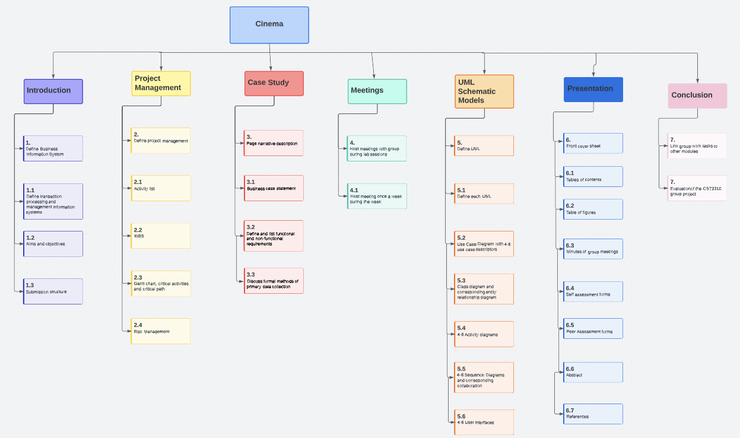
Figure 4 WBS

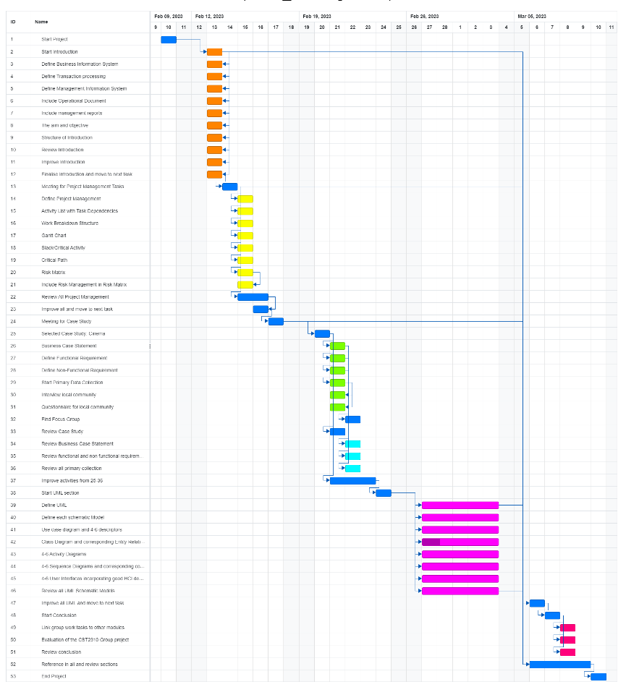
2.4 Gantt Chart, Slack/Critical Activities and Critical Path
Figure 5 Gantt Chart
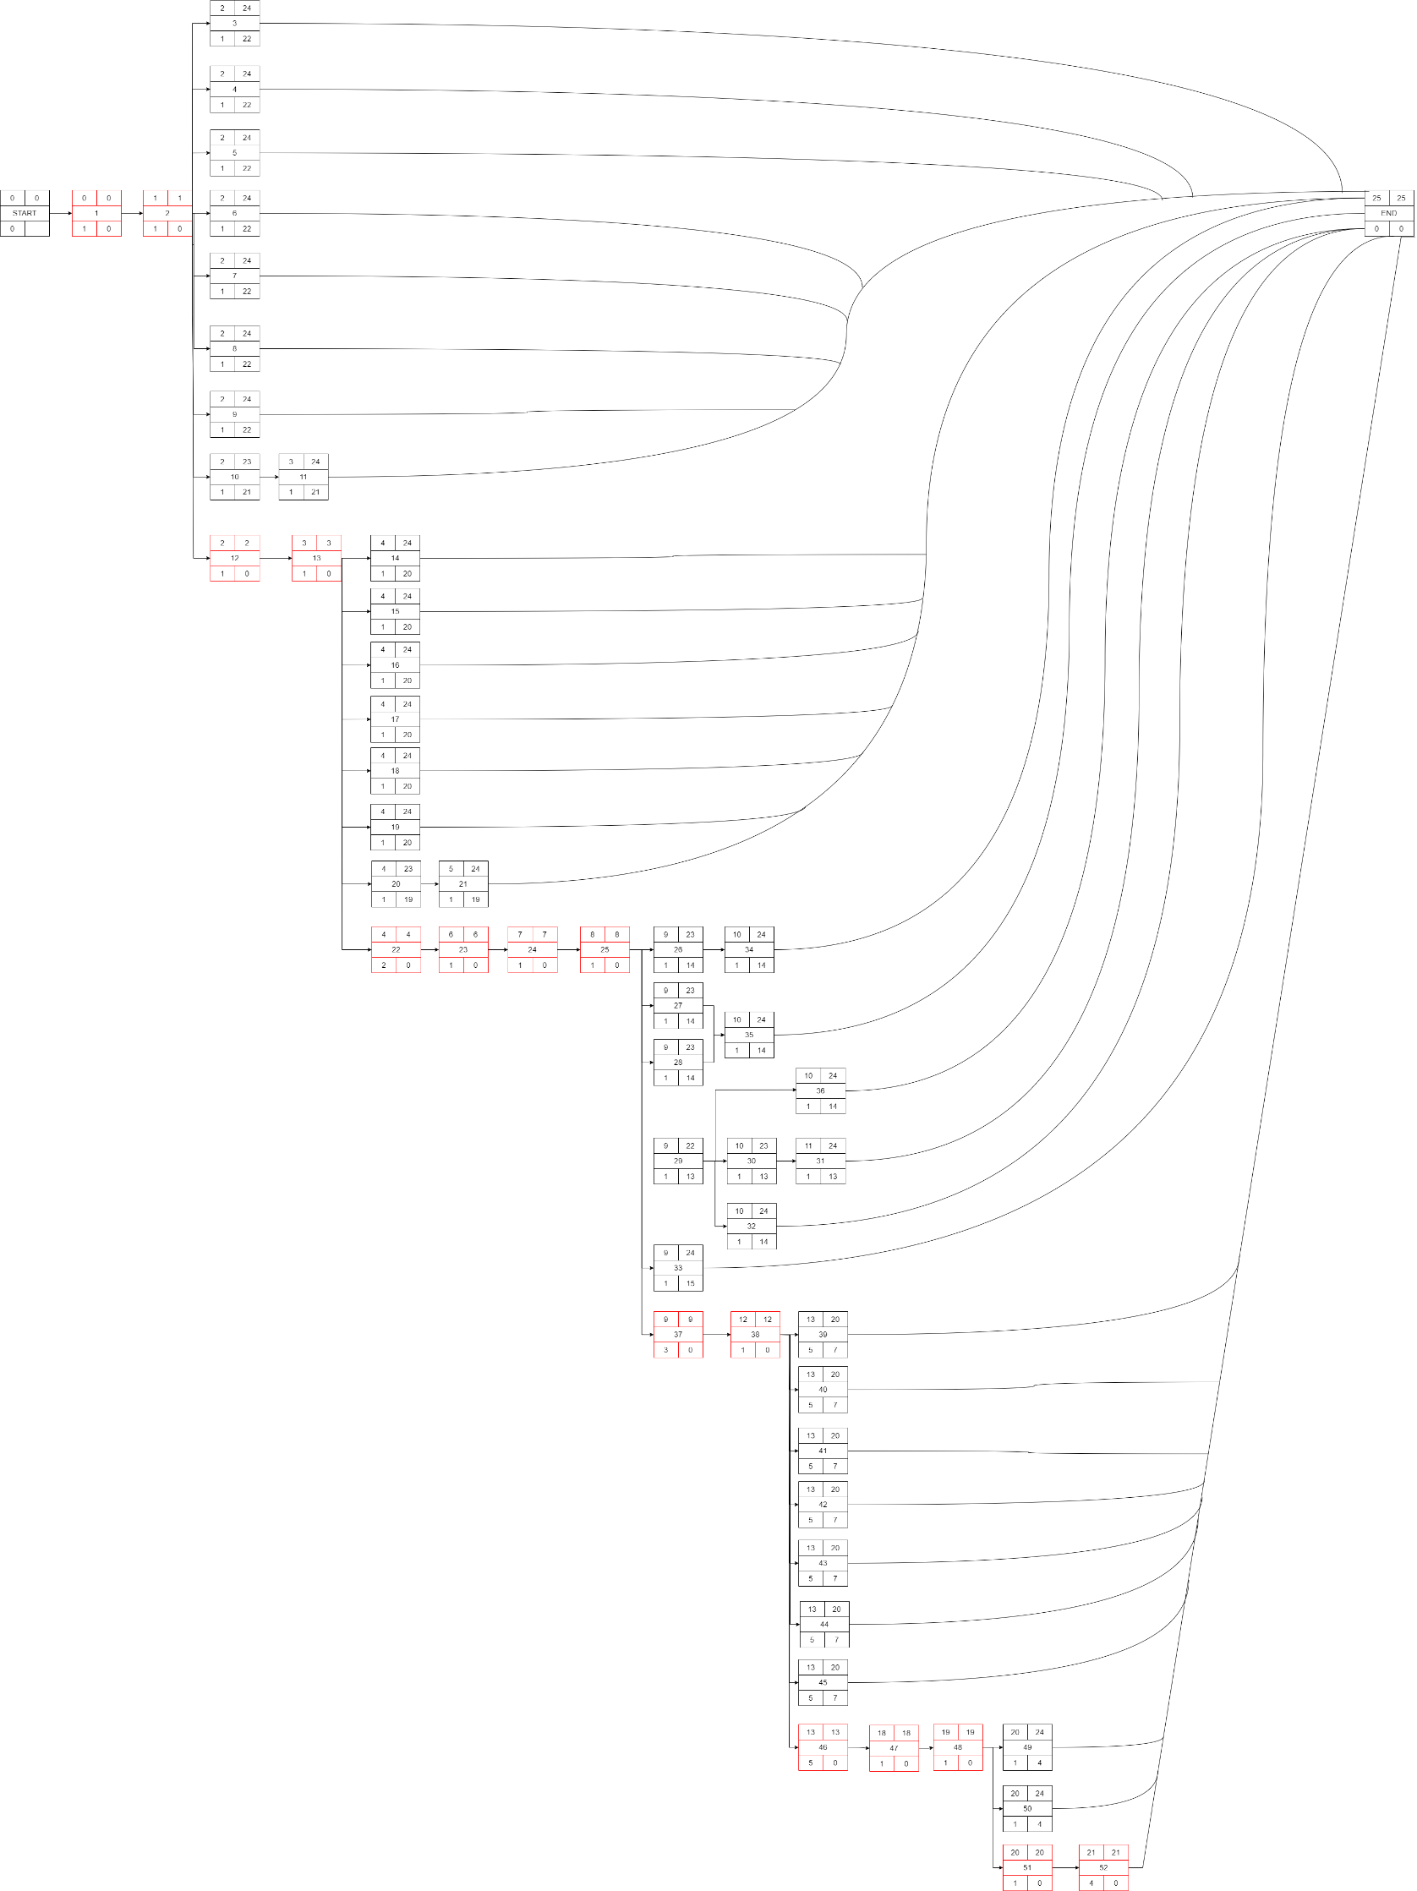
Figure 6 Critical Path
2.5 Risk Management
It is important for businesses to incorporate risk management as it allows them to have as much information as possible which will allow them to stay alert and accountable for any issues that arise and are able to handle it accordingly. (PPH Hotel Group, 2020). It is the continuing process of identification, evaluating, analysing of a business. It monitors the controls and financial resources to prevent or get over a loss. (Marquette 2023)
Risk Description | Potential Impact on Project | Likelihood of Occurrence | Difficulty of Timely Anticipation | Overall, Threat | Contingency/Mitigation
Free Riding.  (Eberly Centre, 2022) | High | Low | Medium | Medium | Use of team contracts.  (Eberly Centre, 2022)
Scheduling Conflicts.  (Iowa State University, 2022) | High | Medium | Low | Medium | Implement use of online tools where necessary.  (Iowa State University, 2022)
Poor communication.  (University of Queensland, 2022) | High | Low | Low | Low | Encourage group members to ask questions rather than making negative assumptions.  (University of Queensland, 2022)
Lack of trust.  (Mandy Flint and Elisabet Vinberg Hearn, 2020) | Low | Low | Medium | Low | Try to get to know all the team members.  (Mandy Flint and Elisabet Vinberg Hearn, 2020)
Domineering group members.  (Learning Hub, 2022) | Medium | Low | Low | Low | Establish talking protocols to allow everyone a chance to speak.  (Learning Hub, 2022)
Accommodation for disabilities.  (DO-IT, 2022) | Medium | Low | High | Medium | Provide them with the resources that help them contribute to the best of their ability based on their disability.  (DO-IT, 2022)
Getting Stuck.  (Harvard University, 2022) | High | High | Medium | High | The best way to resolve such a issue is to ask the right questions for example what are the things that are helping us solve this problem? What's preventing us from solving this problem? Or maybe even take a break and come back to it.  (Harvard University, 2022)
Conform on the majority despite it being the wrong option.  (Principles of Social Psychology - 1st International H5P Edition, 2011) | High | Low | High | High | Having a diverse group allows for different opinions and ideas being available to make better decisions.  (Principles of Social Psychology - 1st International H5P Edition, 2011)

Chapter 3: Case Study
3.1 Narrative description
Electric Cinema is a brand-new company in the entertainment and leisure domain. The company will strive to provide its customers with the most excellent customer service and become a leading company in doing so. The ultimate purpose of Electric Cinema isn’t to just provide a pleasant experience and a venue for people who want to relax during their leisure time by simply viewing a movie. The company wants the clients to really make their money worth by providing additional optional activities that customer can take part in in the build up to their movie of choice as well as gather valuable feedback which will help the company perfect their procedures and aid deliver a positive experience as much as possible in a more interactive manner. The cinema will offer customers the possibility to purchase a membership either paid monthly, quarterly, or annually which will grant the customer with priority on bookings, fast access to movies as only seat booking will be required which will be done via the app/website. The cinema will have a points based system implemented in the mobile phone app as well as on the web application. These points can be obtained in a number of different ways. Each movie booking/ticket purchase will grant the customer with a set amount of points per movie. Points will also be given for feedback at the end of the movie. Any purchase of products at our food/merch kiosk will also be awarded with extra points. A purchase of membership will also grant the customer with a certain number of points based on the membership payment schedule. Thus, this will be the method which grants overall the most points with an annual membership providing the most whilst a monthly membership will credit the client with the least points. The points system is implemented to promote the physical presence of people in our venue and thus promote social interactions and over generate more excitement in going to a cinema. The company advocates for the public to spend less time secluded inside their houses and instead turn up and take part in this activity which ultimately is supposed to likewise individuals together. Finally, the points accumulated will offer customers a number of benefits such as being able to use the points to purchase merchandise/products, food, and even use them as a payment method for memberships.
3.2 Business Case Statement
Electric Cinema will be a cinema based in Borehamwood, a town in southern Hertfordshire with a population of around 31,000. Although there is already a competitor branch in the area, we believe that the capacity of their site compared to the population of the town leaves us an open space to open our service to the local community. Electric Cinema wants to promote the outgoing of citizens to the cinema rather than sitting at home and watching movies as this opens the door for social interactions with other cinema clients and potentially develop new relationships with people within the community.
We understand that therefore, there is need for more than just one cinema based on many factors such as: low availability of tickets at the current cinema, area being highly maintained and continuously developed, commercialization and construction of new headquarters/business sites. These are signs that a new cinema branch in the area could be a good investment for the near future. Having a well-built, user-friendly and intuitive system for the cinema will mean less kiosk staff as customers will be able to use the self-service machines in order to purchase tickets and sign up for memberships. High standard of good customer experience will ensure an increase in the number of customers which in turn will mean more revenue and profit for the cinema resulting into a successful project.
The main risk of this project is not enough customers attraction and therefore lack of clientele. This will obviously result in a very low Return on Investment (ROI). As this is classified as a high importance, high threat, high impact risk, we have considered the possibility of the project not achieving its maximum potential. To lure customers in as quickly as possible, we will offer first-time promotions and long-term benefits for members signing up within the first month of the cinema opening. We firmly believe that the benefits outweigh the risks and the costs of carrying this project through. Costs of the project include cost of land, all constructions related costs, decoration of cinema, utility, electrical and technical components, technology (theater screens, self-service), food & catering, cleaning team, kiosk staff and licensing for the movies and merchandise.
My recommendations for this project are to establish a solid client base within the first weeks of opening the cinema. Having a good designed information system providing a user friendly experience will ensure customer retention as well as new customers.

3.3 Functional Requirements
- Develop a system where potential member can register for and manage their membership.
- Develop a system that produces a financial report and attendance report of members for the manager.
- To develop a system that reminds members of their membership contract ending within a month’s time.
- The system must be able to back up the data in case of imminent system failure.
- Develop a system to separate paid monthly, quarterly, or annually members.
- Develop a system to categorise points system e.g., 100 points premium pointer, 10 points standard pointer.
- Develop a system for points accumulated to purchase merchandise/products, food or for a membership.
- Booking system – to be able to create, cancel and update a booking. A) having a booking ID. B) a user ID. C) a ticket ID
- Ticketing system – To develop a system which will be able to create, cancel, update a ticket. A) by having a ticket ID. B) seat number. C) price. D) date and time.
- Payment system – to be able to take payments from the customers. If customer has membership use the membership ID then A) gather the total cost. B) provide an interface to credit card transaction systems and the Automated Bank Transfer System (ABTS) to process the sale. C) provide a payment ID. If user doesn’t have then customer needs to provide payment method before the total cost can be gathered.
- Staff members – each staff member will have a log in and a different level of access depending on the job role. A) they will each need to have a staff ID. B) A username. C) a password

3.4 Non-Functional Requirements
- The system must be highly secure as it holds sensitive and personal information about customers and bank details.
- The system must be reliable and have a constant uptime of at least 99%
- Procession of membership registration and transaction must be quick and responsive.
- The system must be user friendly for staff to be able to use it and it must be somewhat counter intuitive.
- User interface up to standard, fast loading time and excellent user support in both our mobile app and website.
- The system must be user friendly for customers to be able to use in terms of providing booking confirmation and any other information regarding their purchase in the form of a receipt.
- User should be helped appropriately to fill in the mandatory fields, in case of invalid input.
- System should accept payments via different payment methods, like PayPal, wallets, cards, vouchers, etc.
- Comply with GDPR regulations.
- The system should be regularly maintained to fix any bugs and errors.

3.5 Formal Methods of Primary Data Collection
The method of primary data that we will be in collection for our Electric Cinema is questionnaires in public, to gather the thoughts of the local community. We will be asking questions such as how much you would pay movie ticket, what type of service you expect for example. This can help us understand and act on this primary data information for your business. Another primary data collection that we will be using is interviews because we understand that they can give us their opinion on what we currently are doing well and maybe on what we can improve. Also, it is cost free meaning that it will not have any expenses to the business in anyway, therefore we can gain an insight on your Cinema. The last formal method that we will be using is pitching our product (Electric Cinema) to get a real discussion of your Cinema as they can provide necessary feedback that we can implement. (Datayla, 2020)

Chapter 4: UML Schematic Models

4.1 UML & Each UML Individually Defined
UML is a visual language that helps developer visualise and design diagram and implement it into businesses. They represent the functionality of a business usually and outlines potential rules to solve a problem, for example a sequence diagram based on removing expired membership. (Gliffy, 2020)
Use Case Diagram is a user interaction system that has a variety amount of use case and has different actors, system boundary for it. It is used to summarize a system of a business with different elements, for example ticket or membership system. (Whatis.com, 2023)
Class diagram is an object-oriented model, it is used for a modelling structure of the application and can be used for data modelling. Its purpose is to show structure of system, provides notation for structure and analyse current state of a business. It is made up in classes and relationships. (Visual Paradigm, 2022)
Activity diagram is like a flowchart that shows activities performed by a system. It is a graphical representation of activities which flows from one activity to another. Its purpose is to show a progression of work and describe a business process and can be implemented. (IBM, 2021)
Sequence diagram is an interaction diagram between objects, its focus is to show the order in sequential order and represent the time it taken. Its purpose is to show the order of time and how tasks are taken, and which are returned to the user. The message above the object indicates the return value. (Visual Paradigm, 2022)
Collaboration diagram is used to visualize how the sequence diagram is set up this help. The purpose is to define the roles and responsibilities of the task to which it is done corresponding on sequence diagram. (IBM, 2021)
User Interfaces is the user and a computer system interaction, in particular the use of input devices and software. It is the visual structure of a business; user can visualise and build interfaces. (Interaction design foundation, 2023)

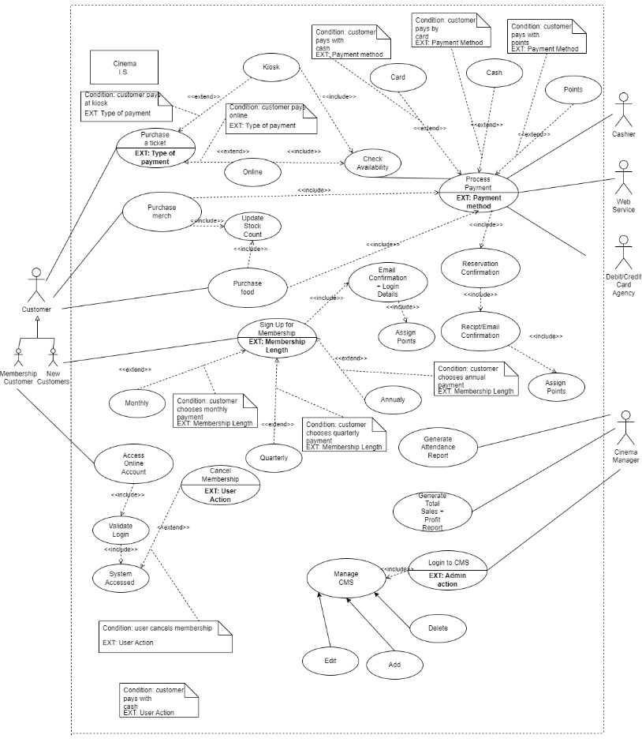
4.2 Use Case Diagram and Descriptors
Figure 7 Use Case

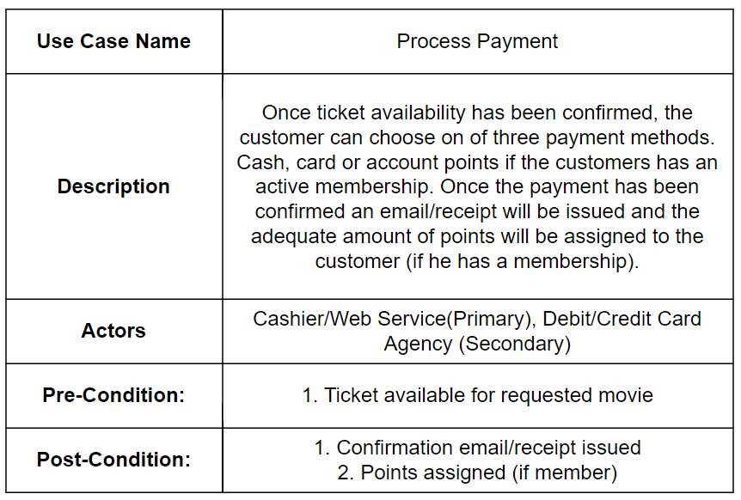
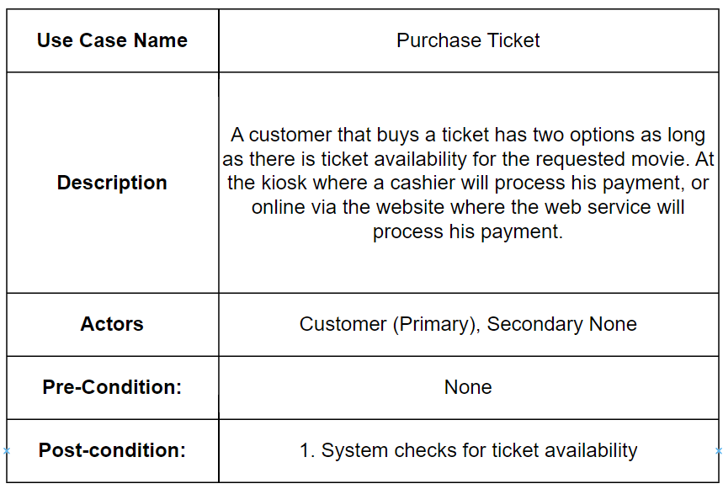
Use Case Descriptions

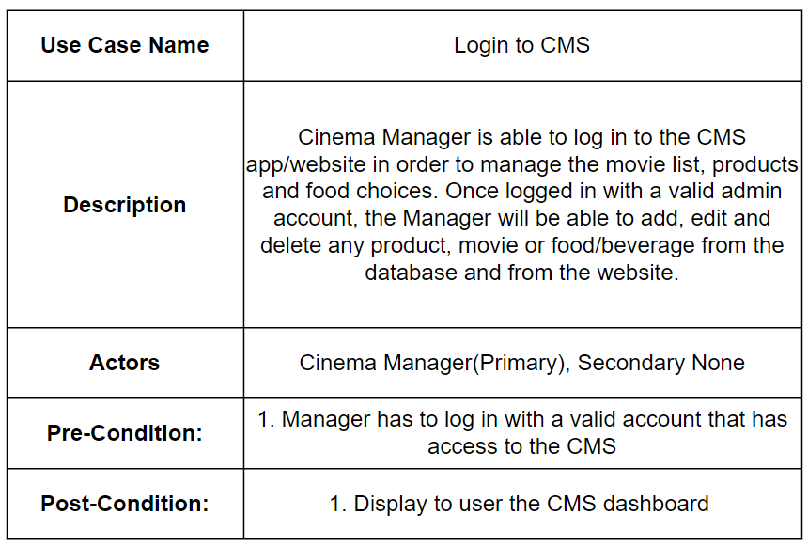
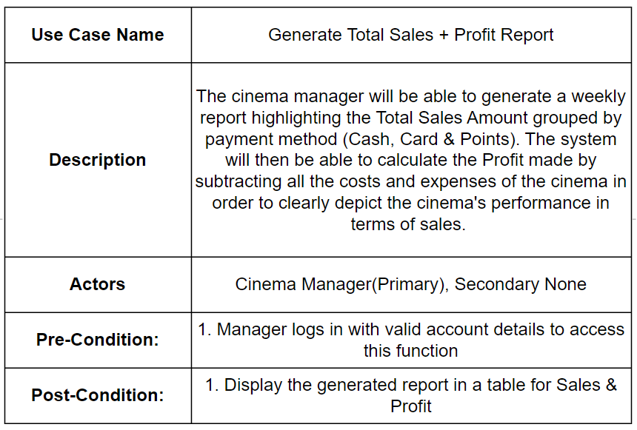
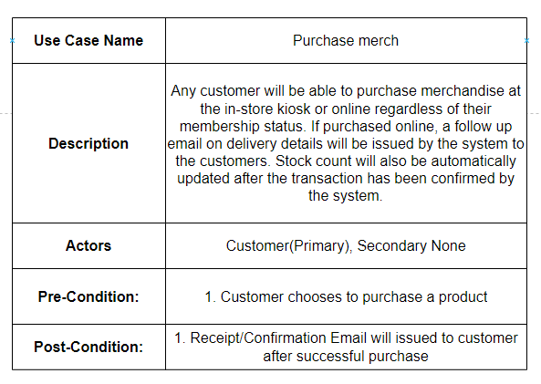
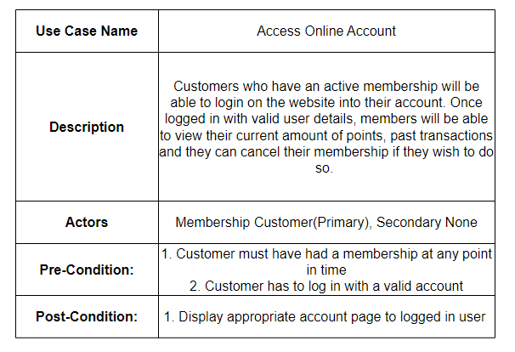

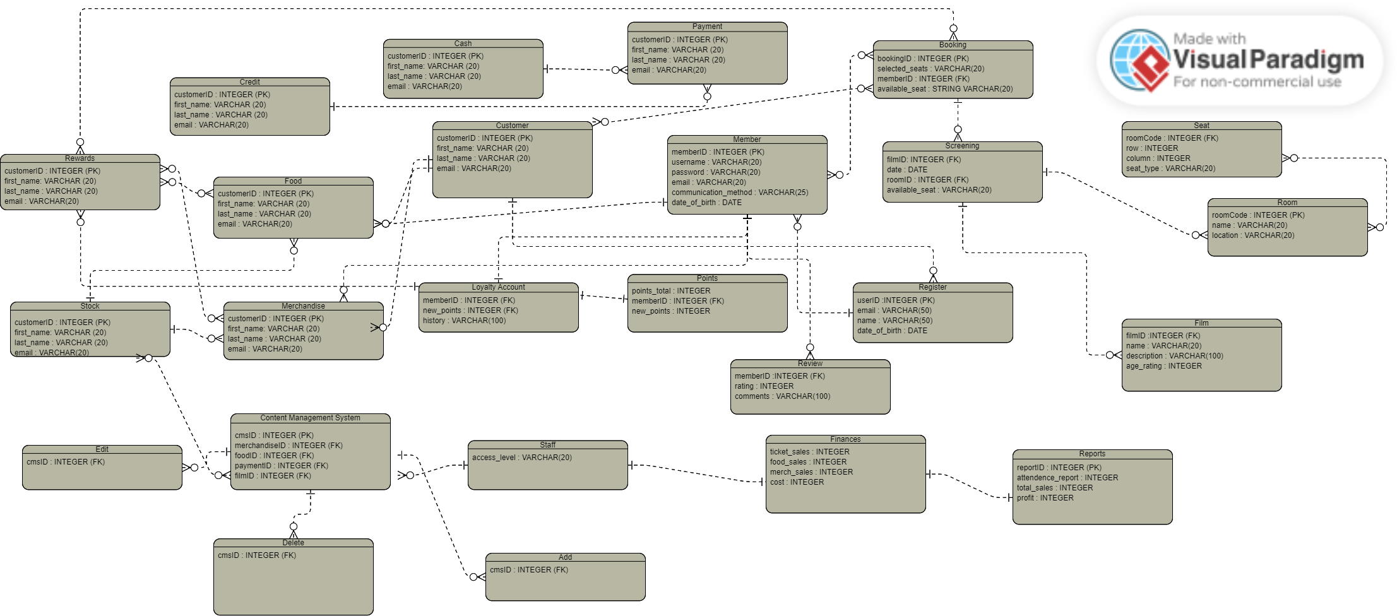
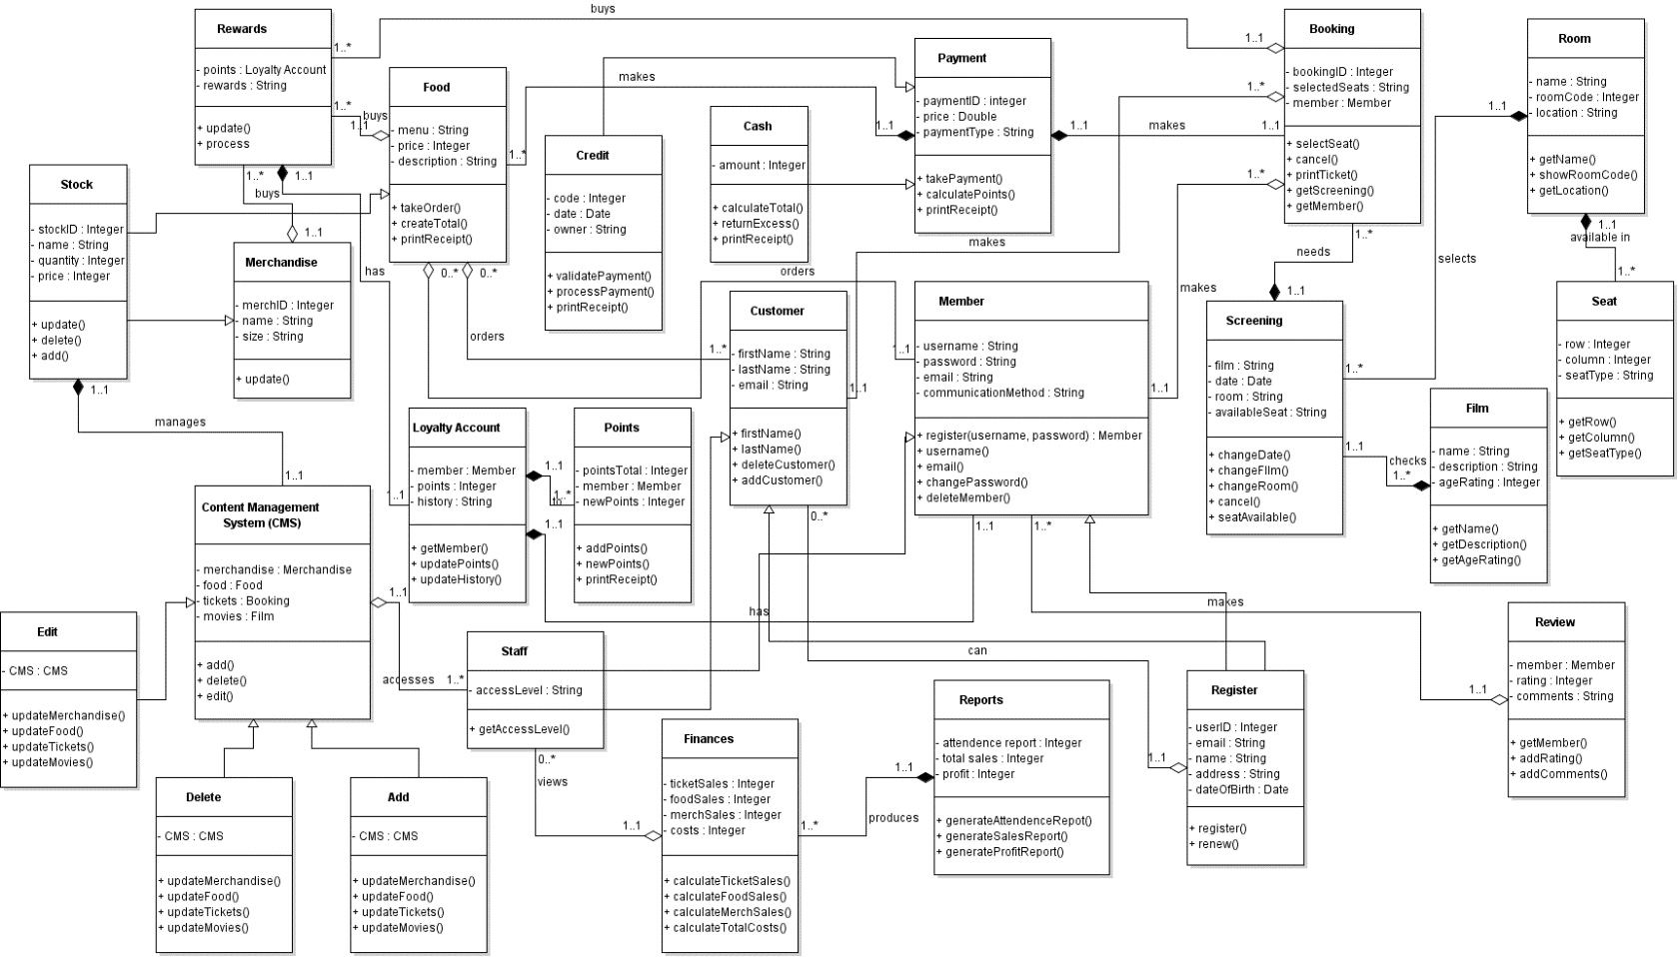
4.3 Class Diagram and Entity Relationship Diagram
Figure 8 Entity Relationship Diagram
Figure 9 Class Diagram

Member will need to register before they can become a member. Then they can make a booking and reviews. Also, they can buy food and merchandise. They will have a loyalty account where the points they collect from their purchases will be added to and then they will get rewards which they can use to buy tickets, food and merchandise.
A customer can also make a booking. They will also be able to make to buy food and merchandise. They will also be able to register to become a member of the cinema.
A booking is initiated when a customer or member wants to buy a ticket. The screening will then check if that is possible by checking the film details for example age restrictions apply. Also the room availability and the corresponding seat availability for the rooms showing the film the purchaser wants.
The staff member will be able to view the finances depending on their access level that they have been permitted to. The financial data will produce reports. The staff will also have access to the content management system (CMS) and this will allow them to add, delete and edit the merchandise, food, film and payment history. They will also be able to manage the stock for the merchandise and by again being able to add, delete and edit.
Their will be payments that will be taken for transactions, and these will either be cash or card payments depending on the purchaser’s preferences.

4.4 Activity Diagram
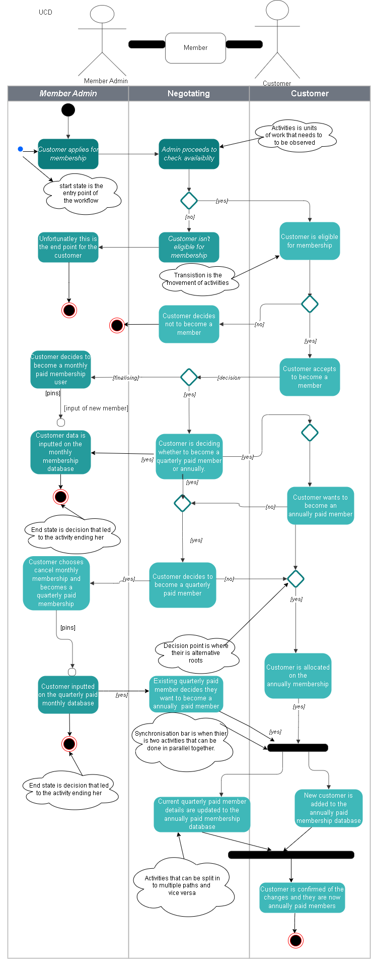
Customer Becoming Member
Figure 10 Activity Diagram 1

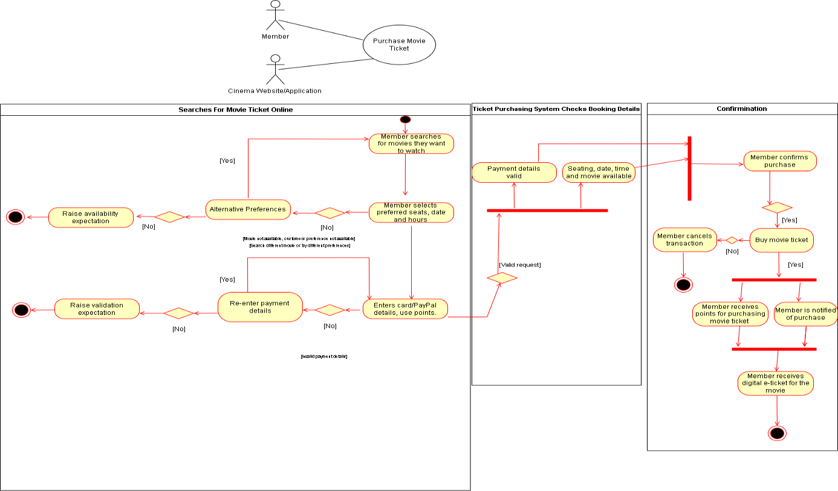
Member Buys Ticket Online
Figure 11 Activity Diagram 2

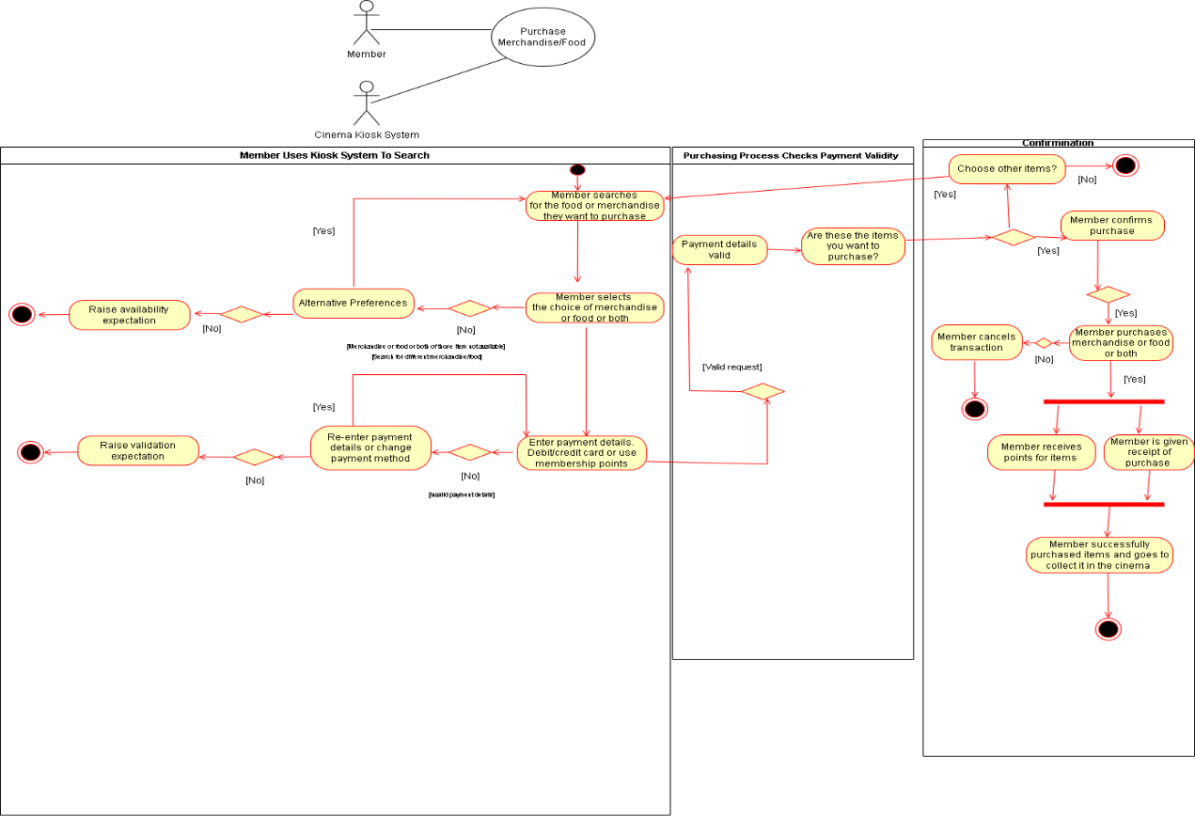
Member Buys Food and/or Merchandise From The Kiosk
Figure 12 Activity Diagram 3
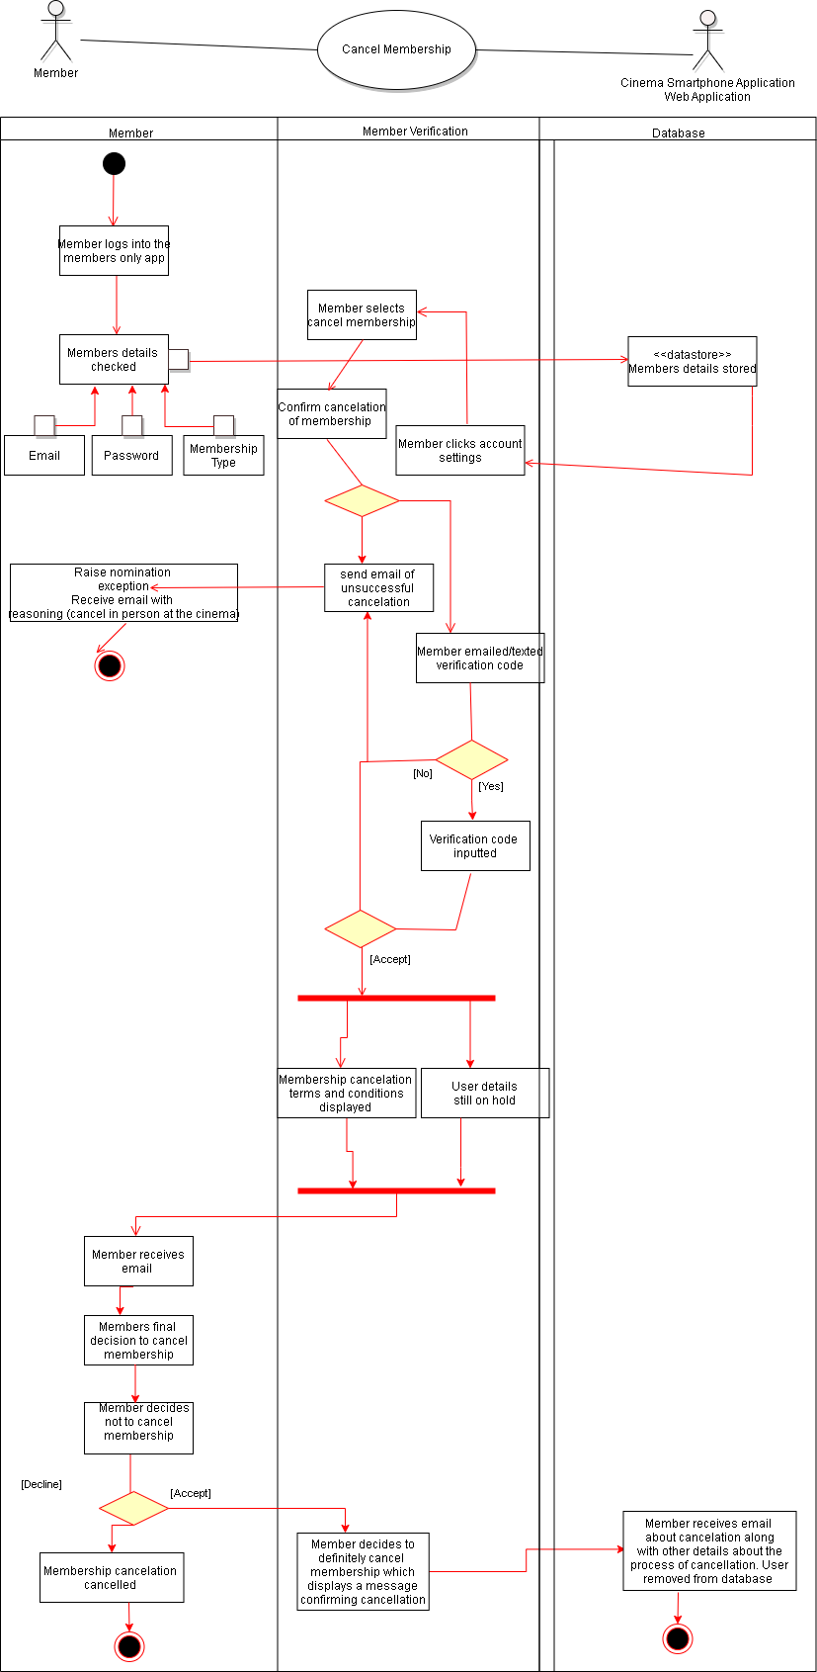
Member Cancels Membership
Figure 13 Activity Diagram 4

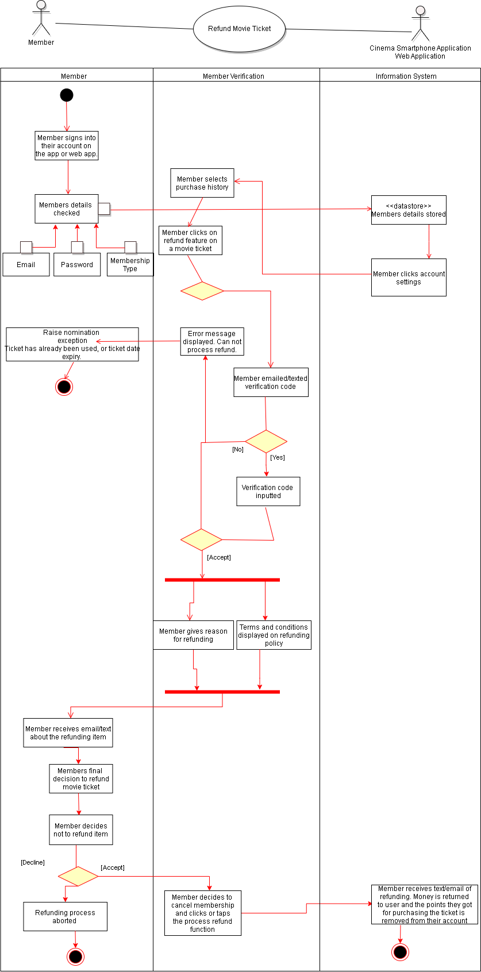
Member Refunds a Movie Ticket
Figure 14 Activity Diagram 5

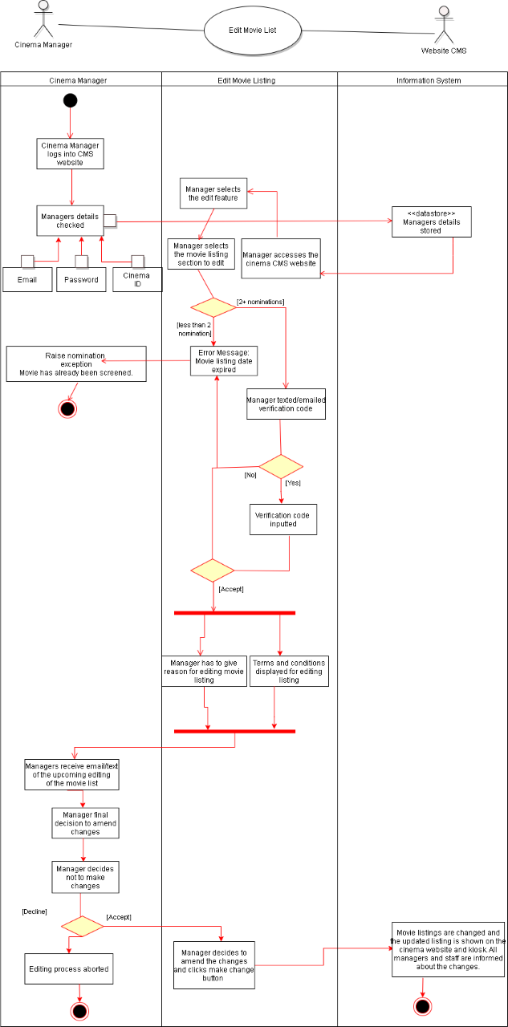
Cinema Manager Edits The Movie List
Figure 15 Activity Diagram 6
4.5 Sequence Diagram and Collaboration Diagram
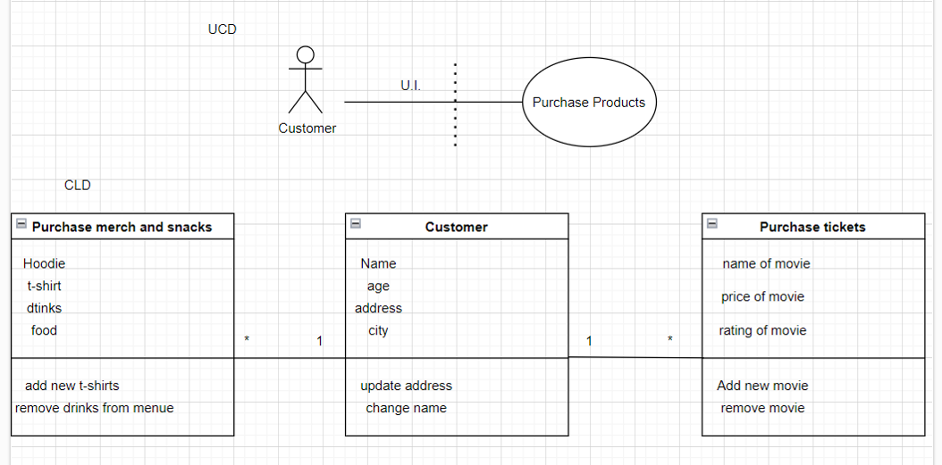
Customer Purchasing Any Product from Electric Cinema
Figure 16 Mini UCD & CLD 1
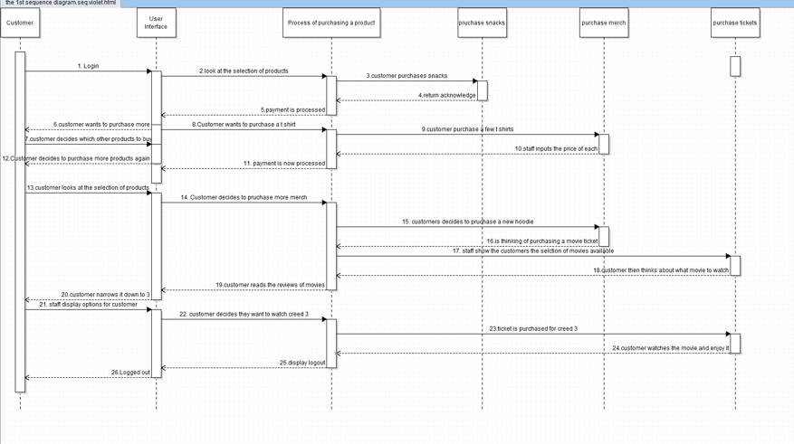
Figure 17 Sequence Diagram 1
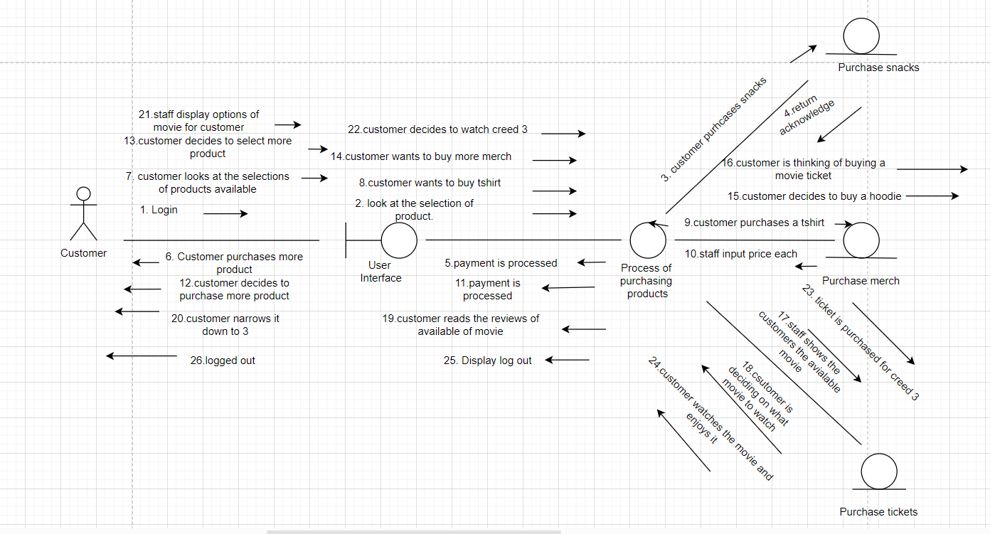
Figure 18 Collaboration Diagram 1
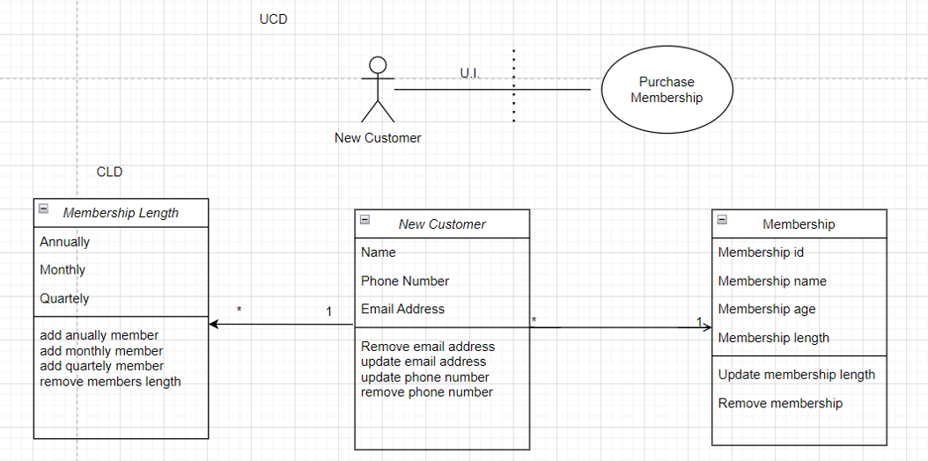
New Customer Purchasing a Membership
Figure 19 Mini UCD and CLD 2

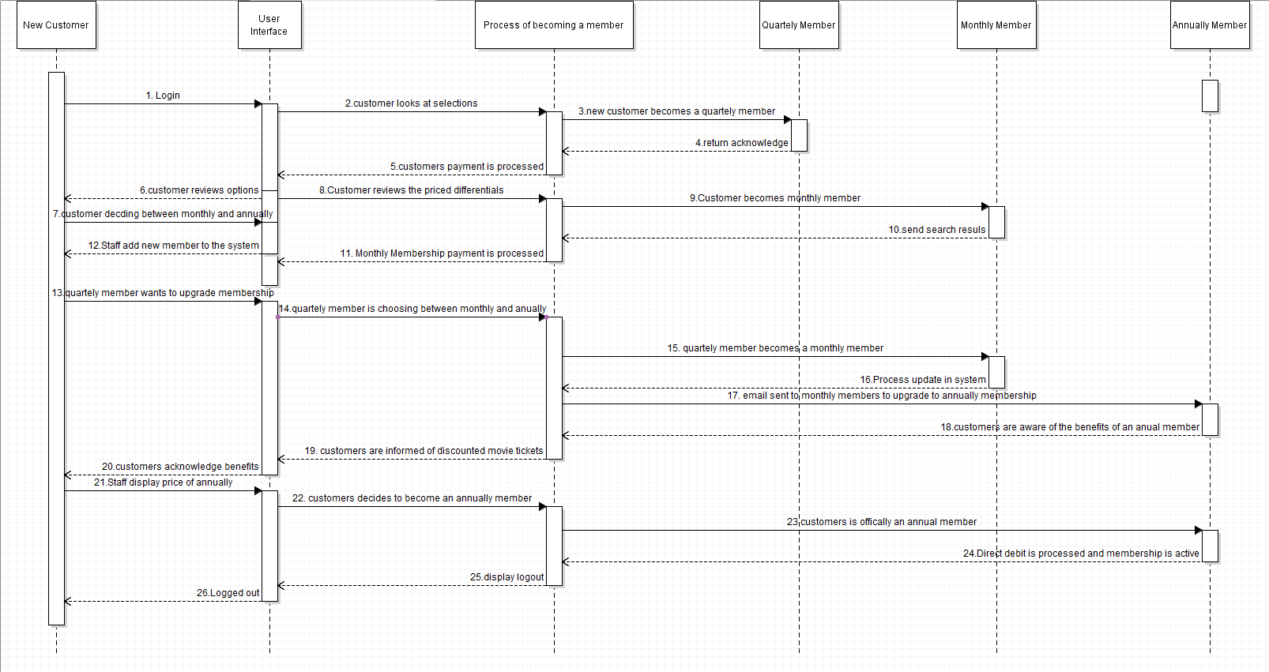
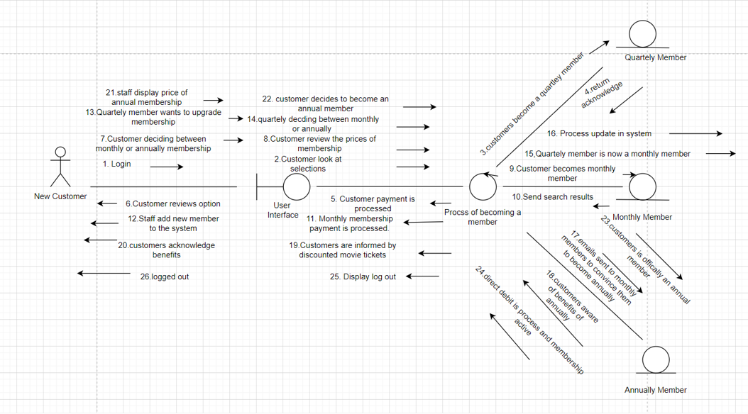
Figure 20 Collaboration Diagram 2
Figure 21 Sequence Diagram 2
Cinema Manager Maintenance of CMS
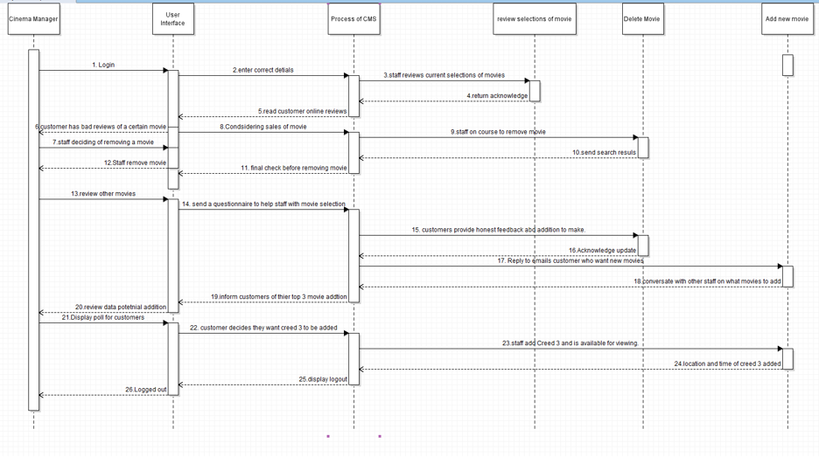
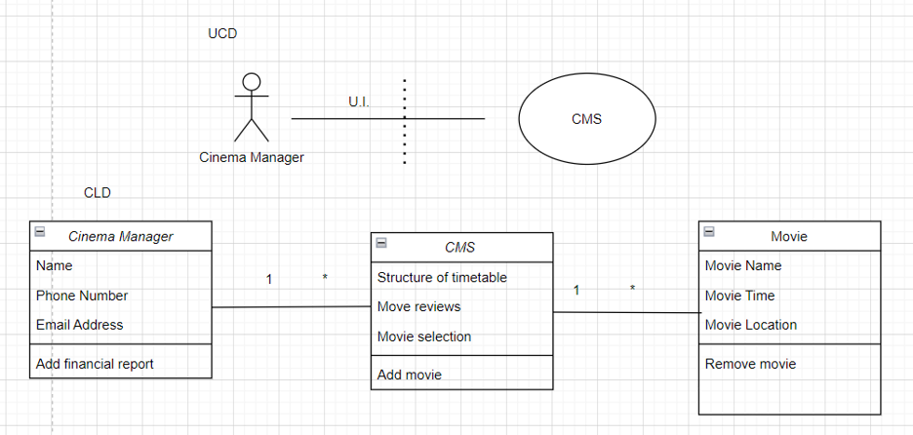
Figure 22 Sequence Diagram 3
Figure 23 Mini UCD and CLD 3
[find bad review]

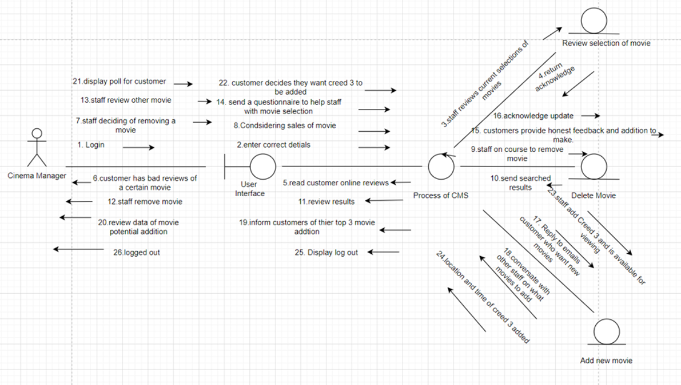
Figure 24 Collaboration Diagram 3
Cashier Payment System
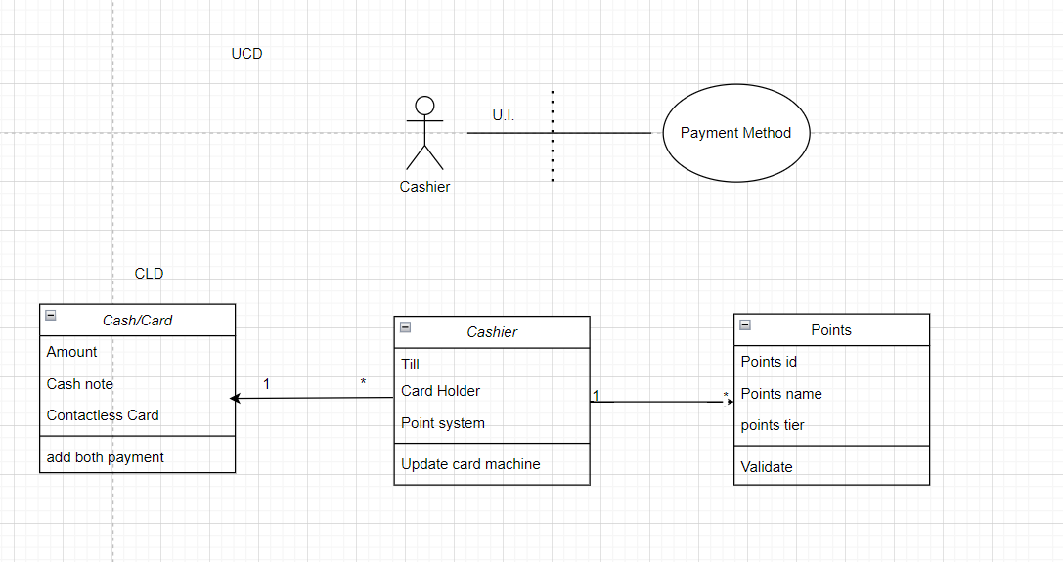
Figure 25 Mini UCD and CLD 4

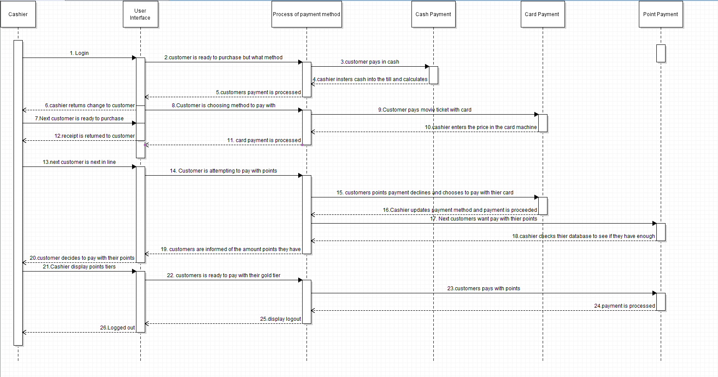
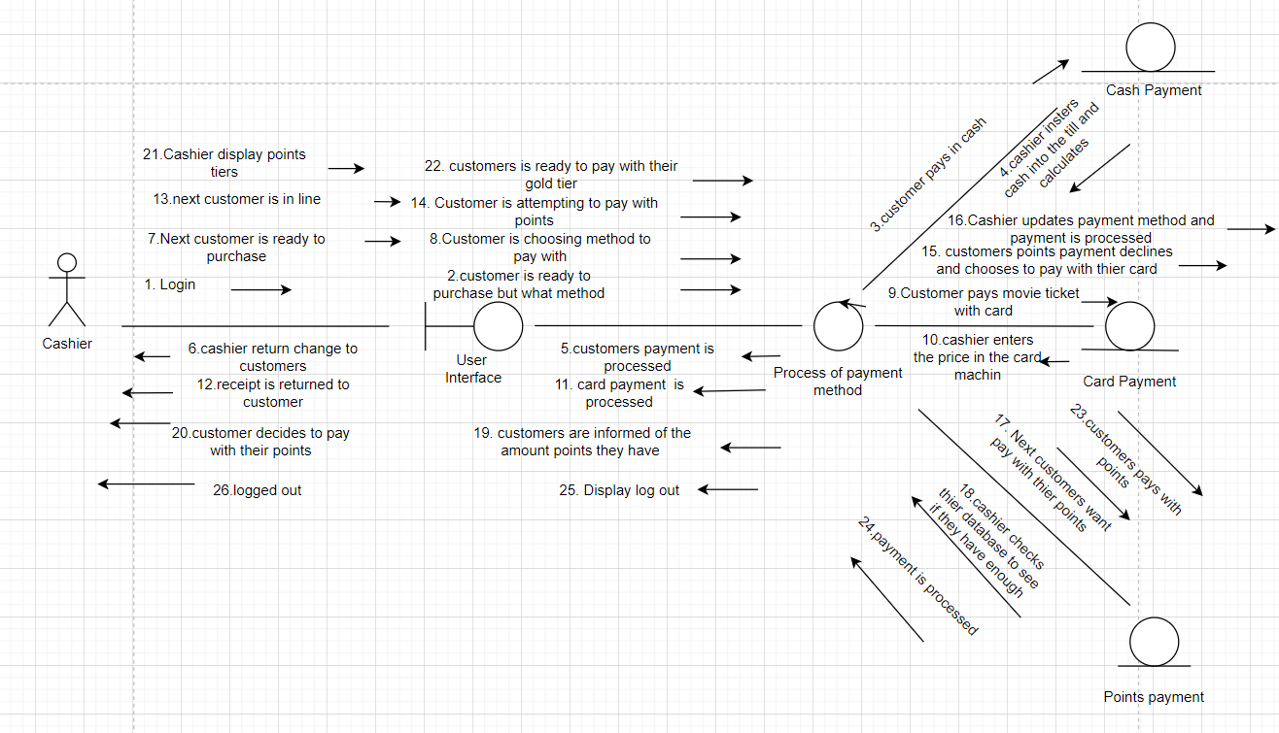
[enough points]
Figure 26 Sequence Diagram 4
Figure 27 Collaboration Diagram 4

Total Sales and Profit Report
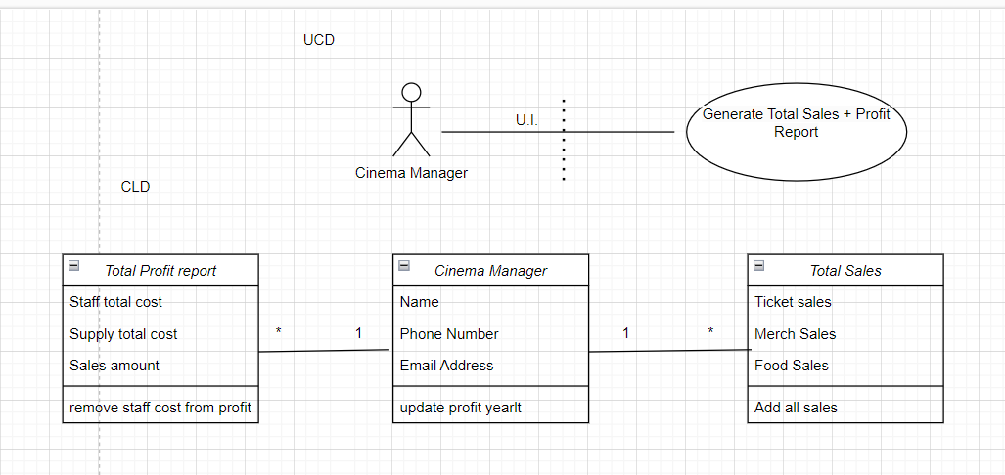
Figure 28 Mini UCD and CLD 5
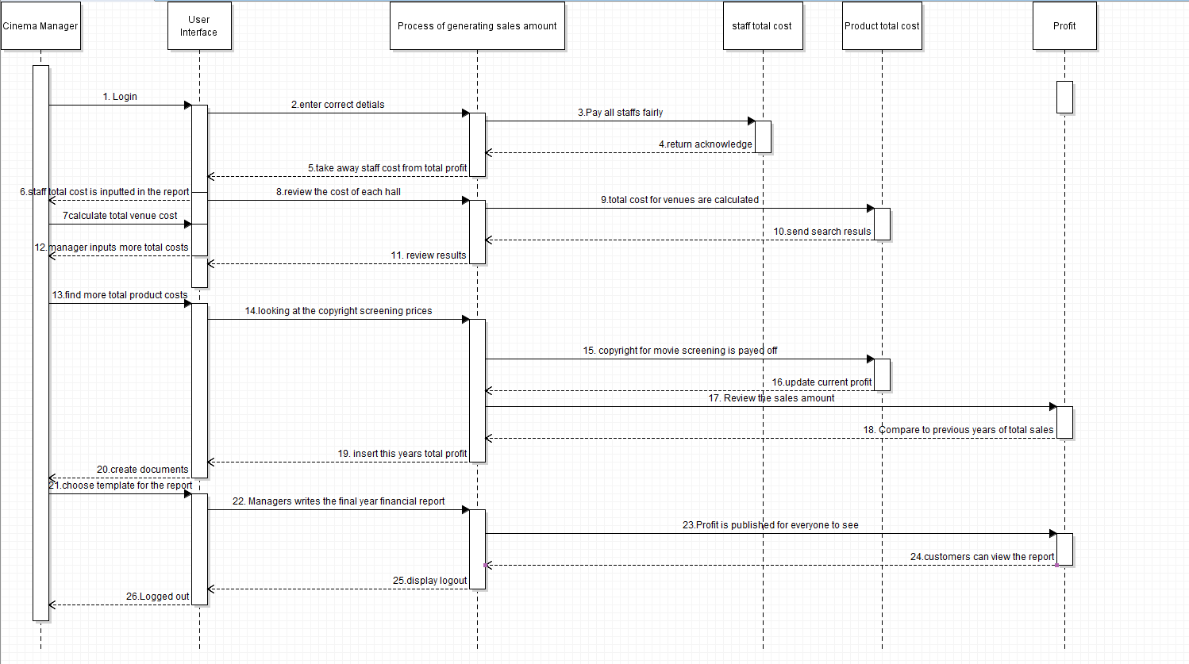
Figure 29 Sequence Diagram 5

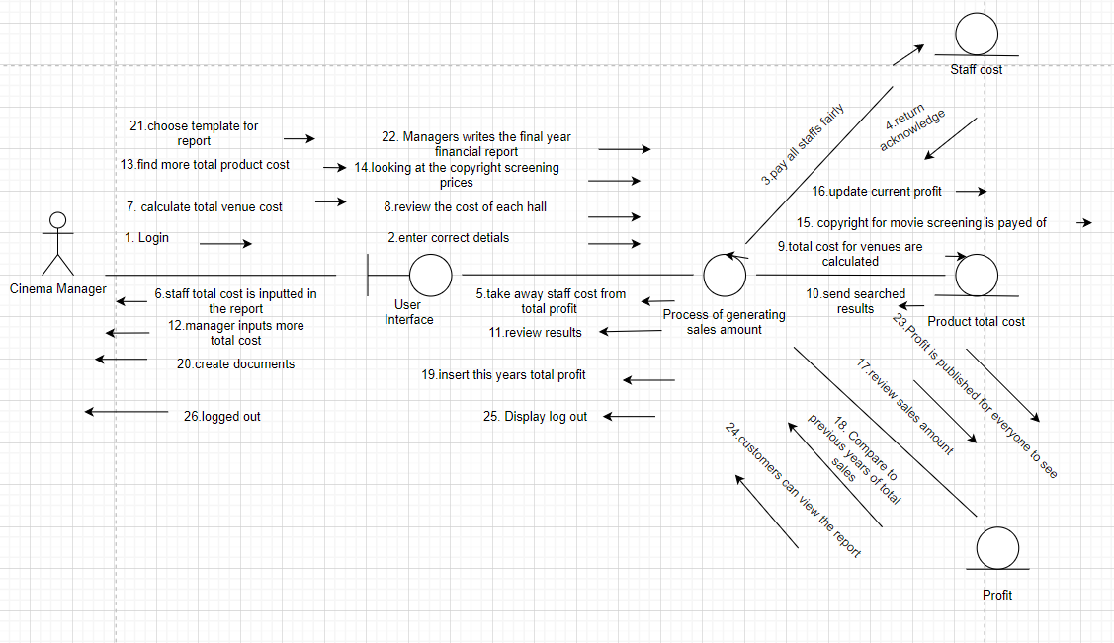
Figure 30 Collaboration Diagram 5
Customer Accessing Online Account
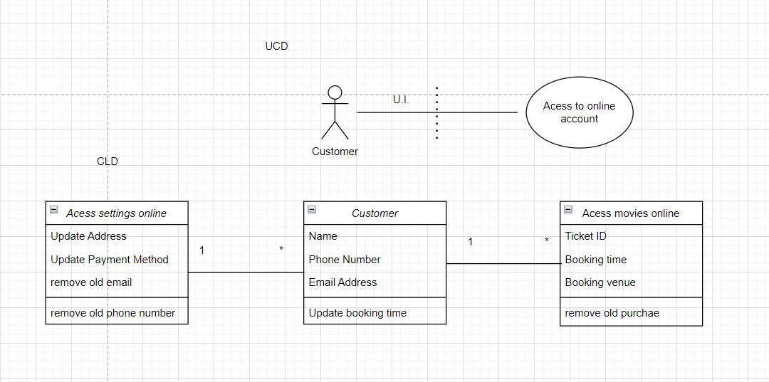
Figure 31 Mini UCD and CLD

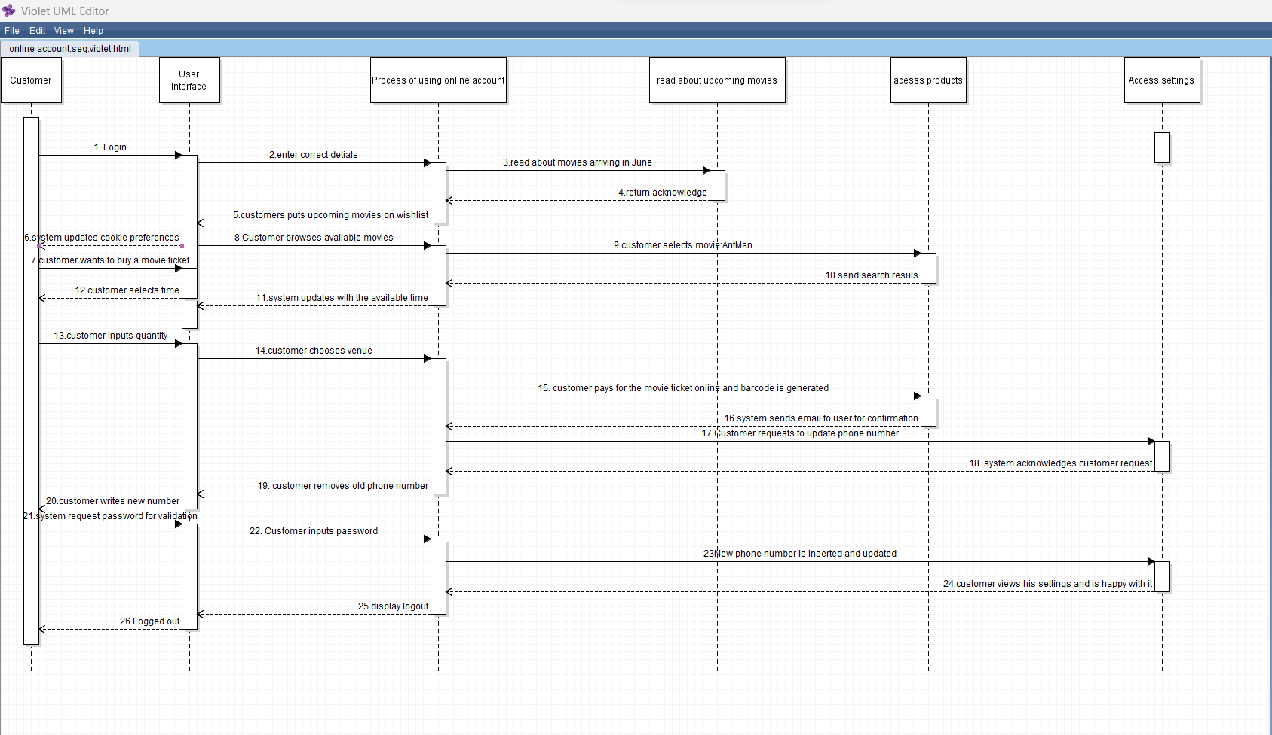
[logged in]
Figure 32 Sequence Diagram 6
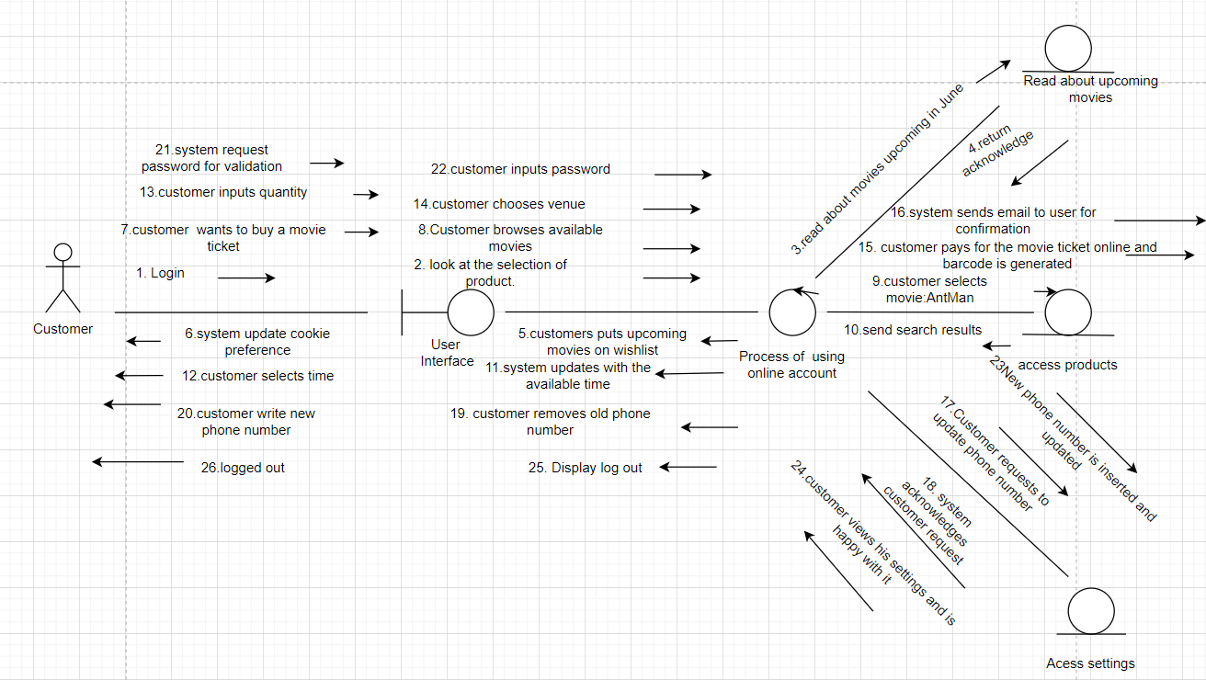
Figure 33 Collaboration Diagram 6
4.6 User Interfaces
We have created wireframes to show the different aspects of the system are intended to look and we have also provided a brief description of how these are good user interface and we have used Nielsen’s heuristics where it outlines 10 principles of good user interface. (Aela, 2023)
The log in system has used a minimalistic design whilst still capturing the aesthetics which would be suitable for a cinema and the company. This is a part of the Nielsen’s heuristics where it declares that functionality is more important than aesthetics. As we can also see in there is help in the login as if the user is struggling to login it suggest what they need to do. For example underneath the submit button there is a link which says ‘Forgot password?’ and this indicated to them they need to click on the link to get help regarding this issue. Another possible problem a user could incur is that they do not have account and therefore need to register, and this is resolved at the bottom of the login form where they are able to click on ‘Register’ and the link will take them to the registration page where they will be able to register and become a member of the Electric cinema. This links Nielsen’s heuristics where it states in the principle there should be help and documentation. (Aela, 2023)

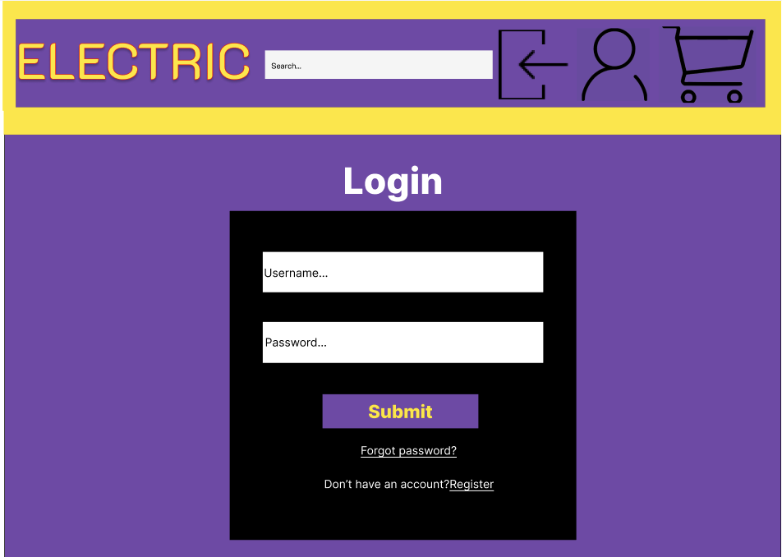
Figure 34 User Interface 1

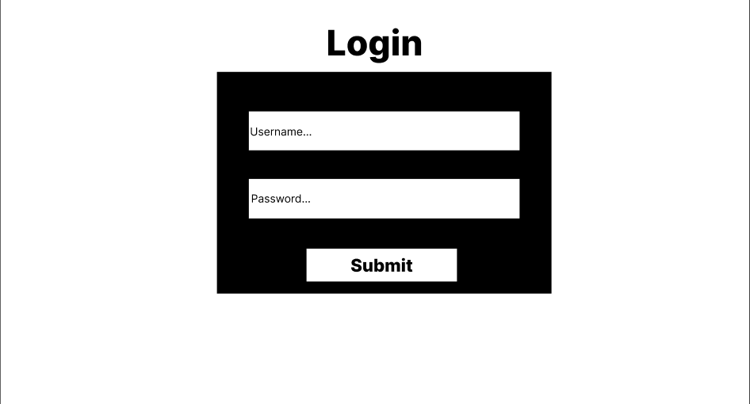
We will also need a log in page for the content management system (CMS) and this looks different to the previous example because if we follow Nielsen’s heuristics then functionality is more important than aesthetics. For the CMS we do not require any styling as it is for the staff only and we also do not require help as they can resolve this in the workplace when they have login issues. (Aela, 2023)
Figure 35 User Interface 2
The registration system is similar to the login system however I would like to discuss in this part how the registration uses recognition rather than recall. If we leave the fields empty then it would be impossible for the user to be able to know what information they are required to input. Therefore as we can see in the wireframe below we have designed it as such so that there are placeholders in place which indicated the information that is required to be entered by the user. (Aela, 2023)
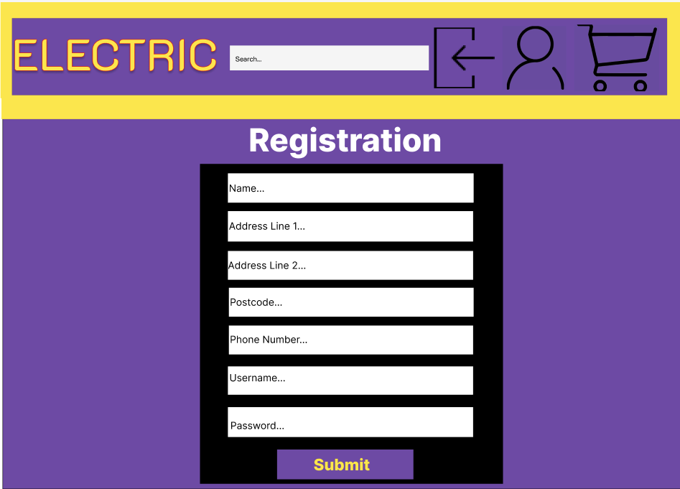
Figure 36 User Interface 3

It is important that we allow users control and freedom according to Nielsen’s heuristics and this is shown in the managing account section. The user is able to carry out many functions in this section using the navigation bar on the right hand side. To make it easier for them to understand what page they are currently that page will be white in the navigation page. The user has many functions available to them which allows them to have the freedom whilst also understanding that they make errors and therefore we do have ‘Edit Details’ and ‘Edit Booking’ in the navigation bar for example. (Aela, 2023)
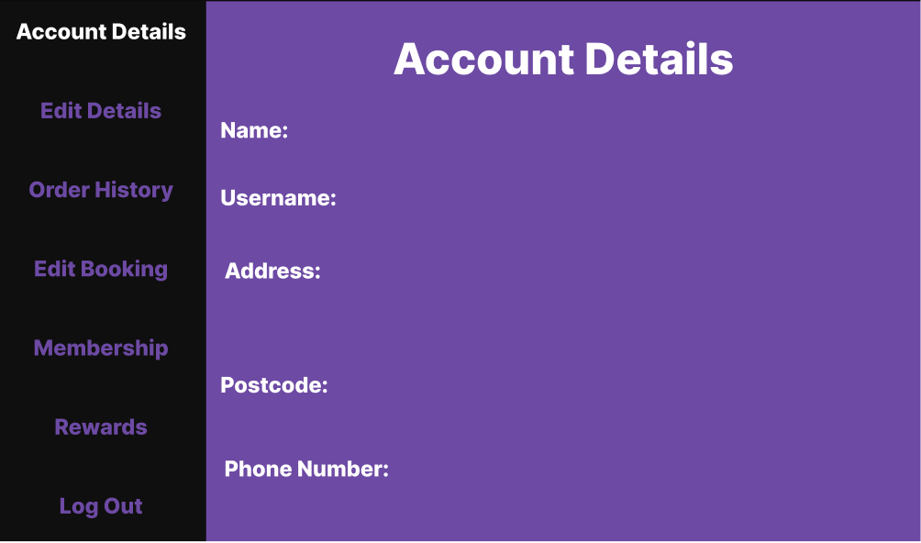
Figure 37 User Interface 4

The confirmation of order as another aspect which incorporates Nielsen’s heuristics as it is an example of visibility od the system status. This is because it provides feedback to the user about their transaction otherwise, they will be confused whether the transaction has gone through. The use of confirmation is predictable, and this is important as builds trust with the customer. (Aela, 2023)
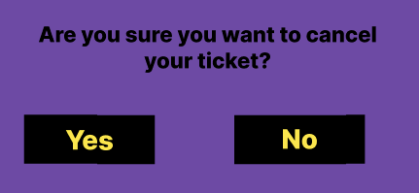
Figure 38 User Interface 5
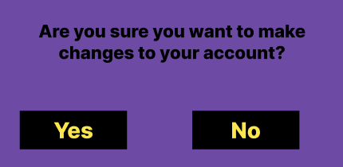
Figure 39 User Interface 6


Figure 40 User Interface 7

Another important factor to consider was error prevention which is included in Nielsen’s heuristics and for this in our system we will use pop ups for cancellation of a ticker, confirmation of edited details and alert for the input of incorrect details. The incorrect details pop will be used for both the log in and registration when the user has entered incorrect details and they have clicked on the ‘Submit’ button. (Aela, 2023)
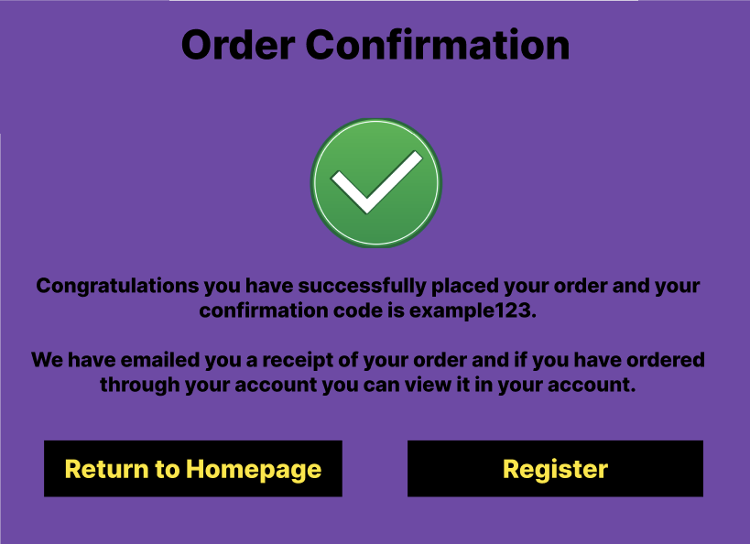
Figure 41 User Interface 8


The navigation bar shows a match between the system and the real world which is another aspect of Nielsen’s heuristics. This is because in the navigation I have used icons which I recognised in the real world for example the login, account and basket. (Aela, 2023)
Figure 42 User Interface 9

Chapter 5: Conclusion

5.1 Link Group Work Tasks to Other Modules
This group tasks are like my other modules on being CST2560 Project Management and Professional Practice, in this particular module we were responsible in dealing with a case study and producing Gantt chart, WBS, critical path and designing. This is directly similar to this coursework (CST2310) to which helps gather previous knowledge and further my understanding in working in a group. The main concept of both were to design models for the user to visualise it and help them understand it. In addition, other group tasks I have helped learn how to communicate, organise and cohesively work together.
Also in CST2120 because we were creating websites and had to use databases. This meant that when creating our UML schematic models we were able to use our knowledge and transfer that onto the model because we understood the functionality to make the website to run efficiently and hopefully this is reciprocated in the design we modelled.

5.2 Self Reflective Statement
In this group Project i have learnt is to work in a group and understanding different perspective and applying it to the work. The personal development that I have learnt in this project is that my communication skills has improved because now I can understand and work in a group a much better. Another personal development tool that I have improved is adaptability because now I can interchange from one activity to another, for example I was meant to do the class diagram however a group member of mine got a better grade and was more confident in producing a more well-rounded diagram, therefore as a group we made the conscious decision for both of us to swap and I was given the tasks to the sequence diagram with corresponding collaborations. Therefore, I can adapt now in any group scenario to which it will help in further projects and help the trajectory of this project. (Abdullahi Mohamed, M00810926)
In the project I have learnt many new skills that I will be able to use in the future in terms of group work and its importance. There are key skills such as communication which you must consider because otherwise it will be difficult to deliver a successful project. Another aspect of group work is understanding that you will need to be flexible because someone may get stuck and even though it is their responsibility to have the task completed you will need to help them and similarly when I was stuck I also had to ask for help and this has helped me improve my technical skills in this module because I have been able to learn from my group members. (Ali Hassan, M00853031)
This group project has improved many of the skills I had previously learnt but to a higher degree now. It taught me the importance of constantly communicating with your team members as well as working together in order to ensure all parts of the project correspond to each other and fit in. I have also learnt many technical skills about Information System Design and project management. I now have a much more complete understanding of how projects should be planned and the process for designing IT system as clearly as possible, making the system user friendly and self intuitive for both the client/users and for the programmers which will actually implement all the functionality of the system. Overall this has been a very positive experience from which I have gained many functional skills in the IT industry which will definitely help me in my career path. (Alessio Dita, M00809761)
For this group project I have learnt many skills which I haven’t learnt before. From technical skills to teamworking skills. There are many benefits I gathered from working in a group, such as. It won’t be that stressful having the whole workload on one person and if you are stuck on a task, you’re team members can help you. For example, I didn’t know how to use Harvard referencing, but I asked my team members on how you do Harvard referencing and they showed me how to do it. Which means I can apply Harvard referencing to my other module assignments. Communication of the group was also very good since we were emailing each other our tasks which we have completed to help each other. In which I can also use this way of communicating in my future jobs. To conclude, I have gained many skills from this group project assignment. Which in then will be beneficial for me in my future careers. (Shoyful Islam, M00811809).

References

- PPH Hotel Group, 2020. Our Approach To Risk Management. Available at: https://www.pphe.com/~/media/Files/P/PPHE-Corp/documents/investors/governance/PPHE_AR20_Approach_Risk_Management.pdf | [Accessed: 10/02/2023]
- Eberly Centre (2022). What are the challenges of group work? Available from Carnegie Mellon University at:
https://ira.aua.am/files/2020/02/WHATAR1.pdf | [Accessed: 16/12/2022]
- Iowa State University (2022). Common group work challenges and solutions? Available from Iowa State University Science and Technology at:
https://www.celt.iastate.edu/instructional-strategies/effective-teaching-practices/group-work/common-group-work-challenges-and-solutions/ | [Accessed: 16/12/2022]
- University of Queensland (2022). Resolving group work Issues. Available from University of Queensland at:
https://my.uq.edu.au/information-and-services/student-support/study-skills/group-work/resolving-group-work-issues#top | [Accessed: 16/12/2022]
- Mandy Flint and Elisabet Vinberg Hearn. Ten common team challenges and how to overcome them. Available from RealBusiness at:
https://realbusiness.co.uk/ten-common-challenges-that-teams-face-and-how-to-overcome-them | [Accessed: 16/12/2022]
- Learning Hub (2022). How to address common group work problems. Available at University of Auckland at:
https://www.learninghub.ac.nz/study-skills/how-to-address-common-group-work-challenges/ | [Accessed: 16/12/2022]
- DO-IT (2022). Groupwork/Discussions. Available from University of Washington at:
https://www.washington.edu/doit/group-workdiscussions | [Accessed: 16/12/2022]
- Harvard University (2022). Group Work. Available from Harvard University at:
https://bokcenter.harvard.edu/group-work | [Accessed: 16/12/2022]
- Principles of Social Psychology - 1st International H5P Edition (2011). Available from BCampus at:
https://opentextbc.ca/socialpsychology/chapter/group-decision-making/ | [Accessed: 16/12/2022]
- Project Management Institute (2000 Edition), “A Guide to the Project Management Body of Knowledge”, (“PMBOK ® Guide”), “WHAT IS PROJECT MANAGEMENT?” ![date accessed 10th February 2023]
- APM Association for Project Management (2022), “What is project management?”, available from APM, Association of Project Management at: https://www.apm.org.uk/resources/what-is-project-management/ ![date accessed 17th February 2023
- Mississippi state University(2023), What is Business Information System?, available from college of business at: https://www.business.msstate.edu/academics/department-management-information-systems/business-information-systems ![date accessed 18th February 2023]
- Marquette (2023), what is risk management available from Marquette at: https://www.marquette.edu/riskunit/riskmanagement/whatis ![date accessed 10th February 2023]
- Datayla(2020), methods of primary data available from Datayla at: 5 Traditional Methods of Primary Data Collection | Data Science Blog (datalya.com) ![date accessed 18th February 2023]
- Gliffy(2020), What is UML? available from Gliffy at: What is UML? Unified Modelling Language Explained | Gliffy by Perforce ![date accessed 18th February 2023]
- Whatis.com(2023), what is a Use Case Diagram, available from Tech Target at: https://www.techtarget.com/whatis/definition/use-case-diagram# ![date accessed 18th February 2023]
- Visual Paradigm(2022),What is class diagram, available from visual paradigm at: https://www.visual-paradigm.com/guide/uml-unified-modeling-language/what-is-class-diagram/ ![date accessed 18th February 2023]
- IBM(2021),What is a activity diagram, available from Rational software model at: https://www.ibm.com/docs/en/rsm/7.5.0?topic=diagrams-activity![date accessed 18th February 2023]
- Visual Paradigm(2022), what is a sequence diagram, available from visual paradigm at: https://www.visual-paradigm.com/guide/uml-unified-modeling-language/what-is-sequence-diagram/ ![date accessed 18th February 2023]
- IBM(2021),What is collaboration?, available from Rational software model at: https://www.ibm.com/docs/en/rsas/7.5.0?topic=diagrams-collaborations ![date accessed 18th February 2023]
- Interaction design foundation (2023), what is a user interface design?, available from at interaction design foundation https://www.interaction-design.org/literature/topics/ui-design ![ date accessed 18th February 2023]
- Aela (2023), Nelsen’s Heuristics: 10 Usability Principles To Improve UI Design. Available from Aela at: https://aelaschool.com/en/interactiondesign/10-usability-heuristics-ui-design/ | [Accessed: 03/03/2023]
- Stair, R.M. (2021). Principles of information systems. Boston, Ma, Usa: Cengage.
Olivia (2011). Difference Between TPS and MIS. [online] Compare the Difference Between Similar Terms. Available at: https://www.differencebetween.com/difference-between-tps-and-vs-mis/#:~:text=TPS%20tracks%20daily%20routine%20transactions | [Accessed: [10/03/2023]

Appendix
Group Meetings
Date of meeting: 10/02/22 Time of meeting: 10:00-12:00

Members Present: Ali Hassan; Abdullahi Mohamed; Alessio Dita & Shoyful Islam

Apologies from: N/A

Items Discussed:
Group leader
Discussed the project we are going to use.
Problems encountered:
Slight disagreement on the case study to use.
Tasks/Deliverables for next meeting:
Produce case studies individually to present on the next meeting and vote for the final case study.
Student Name: Ali Hassan

Student Signature…………………………………

Student Name: Abdullahi Mohamed

Student Signature………………………………….

Student Name: Alessio Dita

Student Signature………………………………….

Student Name: Shoyful Islam

Student Signature………………………………….

Date of meeting: 15/02/22 Time of meeting: 14:00-15:00

Members Present: Ali Hassan; Abdullahi Mohamed; Alessio Dita & Shoyful Islam
Apologies from: N/A
Items Discussed:
Finalising the case study
Problems encountered:
Any disagreements were resolved in the vote, and we discussed adding additional parts to the case study that was chosen were discussed.
Tasks/Deliverables for next meeting:
Everyone contributes functional and non-functional requirements.
Student Name: Ali Hassan

Student Signature…………………………………

Student Name: Abdullahi Mohamed

Student Signature………………………………….

Student Name: Alessio Dita

Student Signature………………………………….

Student Name: Shoyful Islam

Student Signature………………………………….

Date of meeting: 17/02/22 Time of meeting: 10:00-12:00

Members Present: Ali Hassan; Abdullahi Mohamed; Alessio Dita & Shoyful Islam
Apologies from: N/A
Items Discussed:
Splitting all the remaining tasks
Functional and non-functional requirements
Problems encountered:
Everyone seemed to want to do similar tasks however this was resolved, and everyone accepted that tasks that they were expected to be completed
Tasks/Deliverables for next meeting:
Make a start on the tasks that each individual was allocated in particular focussing on chapters 1,2 and 3.
Student Name: Ali Hassan

Student Signature…………………………………

Student Name: Abdullahi Mohamed

Student Signature………………………………….

Student Name: Alessio Dita

Student Signature………………………………….

Student Name: Shoyful Islam

Student Signature………………………………….

Date of meeting: 22/02/22 Time of meeting: 14:00-15:00

Members Present: Ali Hassan; Abdullahi Mohamed; Alessio Dita & Shoyful Islam

Apologies from: N/A

Items Discussed:
Catch up and opportunity to discuss any problems anyone has encountered.
Problems encountered:
Everyone seemed to understand what they were expected to do, and a reasonable amount of work had been achieved.
Tasks/Deliverables for next meeting:
Expectation was to be ready to send in completed work to the group leader so that person is able to add everyone contribution into the portfolio.
Student Name: Ali Hassan

Student Signature…………………………………

Student Name: Abdullahi Mohamed

Student Signature………………………………….

Student Name: Alessio Dita

Student Signature………………………………….

Student Name: Shoyful Islam

Student Signature………………………………….

Date of meeting: 24/02/22 Time of meeting: 10:00-12:00

Members Present: Ali Hassan; Abdullahi Mohamed; Alessio Dita & Shoyful Islam

Apologies from: N/A

Items Discussed:
Assessment on how much everyone had done and if anybody had completed any of the tasks.
Problems encountered:
No problems were encountered everyone had completed most of their tasks from chapters 1,2 and 3.
Tasks/Deliverables for next meeting:
Everyone is expected to start their allocated UML diagrams and any issues they may have can be discussed in the following meeting.
Student Name: Ali Hassan

Student Signature…………………………………

Student Name: Abdullahi Mohamed

Student Signature………………………………….

Student Name: Alessio Dita

Student Signature………………………………….

Student Name: Shoyful Islam

Student Signature………………………………….

Date of meeting: 01/03/22 Time of meeting: 14:00-15:00

Members Present: Ali Hassan; Abdullahi Mohamed; Alessio Dita & Shoyful Islam

Apologies from: N/A

Items Discussed:
Assessment on how much everyone had done and if anybody had completed any concern regarding the tasks.
Problems encountered:
Discussion on the class diagram as there was a bit of confusion.
Tasks/Deliverables for next meeting:
Carry on with allocated tasks for review and in particular the class diagram to see if all issues have been resolved.
Student Name: Ali Hassan

Student Signature…………………………………

Student Name: Abdullahi Mohamed

Student Signature………………………………….

Student Name: Alessio Dita

Student Signature………………………………….

Student Name: Shoyful Islam

Student Signature………………………………….

Date of meeting: 03/03/22 Time of meeting: 10:00-12:00

Members Present: Ali Hassan; Abdullahi Mohamed; Alessio Dita & Shoyful Islam

Apologies from: N/A

Items Discussed:
Catch up and discussed if anyone had any problems that they require help with.
Problems encountered:
n/a
Tasks/Deliverables for next meeting:
Everyone should have their UML schematic models completed by the next scheduled meeting on 08/032023. If anyone is struggling they should indicate this before the meeting and one of the other group members should help him.
Student Name: Ali Hassan

Student Signature…………………………………

Student Name: Abdullahi Mohamed

Student Signature………………………………….

Student Name: Alessio Dita

Student Signature………………………………….

Student Name: Shoyful Islam

Student Signature………………………………….

Date of meeting: 08/03/22 Time of meeting: 14:00-15:00

Members Present: Ali Hassan; Abdullahi Mohamed; Alessio Dita & Shoyful Islam

Apologies from: N/A

Items Discussed:
Catch up and discussed if anyone had any problems that they require help with.
Problems encountered:
n/a
Tasks/Deliverables for next meeting:
Have all the UML diagrams completed by the 9th of March to have checked by fellow group members by the 10th of March and handed in into the group leader who should start preparing the document ready for submission.
Student Name: Ali Hassan

Student Signature…………………………………

Student Name: Abdullahi Mohamed

Student Signature………………………………….

Student Name: Alessio Dita

Student Signature………………………………….

Student Name: Shoyful Islam

Student Signature………………………………….

Date of meeting: 10/03/22 Time of meeting: 10:00-13:00

Members Present: Ali Hassan; Abdullahi Mohamed; Alessio Dita & Shoyful Islam

Apologies from: N/A

Items Discussed:
Catch up and completion of the appendix.
Problems encountered:
n/a
Tasks/Deliverables for next meeting:
This was the last meeting and submission should be completed before the end of the meeting.
Student Name: Ali Hassan

Student Signature…………………………………

Student Name: Abdullahi Mohamed

Student Signature………………………………….

Student Name: Alessio Dita

Student Signature………………………………….

Student Name: Shoyful Islam

Student Signature………………………………….

Self Assessment Forms and Reflective Statement
Using the scale of 0 to 5 please provide a critical appraisal of what has been achieved, and of your contribution and of the other team members’ contribution.
0 = Absent (or Very Poor)
1 = Poor
2 = Satisfactory
3 = Good
4 = Very Good
5 = Excellent

Self Assessment

- How would you rate your technical contribution to the group work? 4

- How would you rate your contribution in terms of organisation? 5

- How would you rate your contribution in terms of communication? 5

- The holistic view of things argues that group work has more benefits than drawback and that groups always achieve more and better results than people working as individuals. Please rank the following in order of importance in the context of group work (using 1 for the most important):

Benefit | Ranking
Sharing of knowledge | 2
Sharing the work load | 1
Enhancing Communication | 6
Compromise/Listening to others | 3
Obtaining additional perspectives | 5
Providing Mutual Support | 4
Learning from teaching others | 7

Please insert your name and your Student Number below

Name: Ali Hassan

Student No: M00853031

Self Assessment Forms and Reflective Statement
Using the scale of 0 to 5 please provide a critical appraisal of what has been achieved, and of your contribution and of the other team members’ contribution.
0 = Absent (or Very Poor)
1 = Poor
2 = Satisfactory
3 = Good
4 = Very Good
5 = Excellent

Self Assessment

- How would you rate your technical contribution to the group work? 4

- How would you rate your contribution in terms of organisation? 3

- How would you rate your contribution in terms of communication? 4

- The holistic view of things argues that group work has more benefits than drawback and that groups always achieve more and better results than people working as individuals. Please rank the following in order of importance in the context of group work (using 1 for the most important):

Benefit | Ranking
Sharing of knowledge | 1
Sharing the work load | 3
Enhancing Communication | 5
Compromise/Listening to others | 4
Obtaining additional perspectives | 6
Providing Mutual Support | 7
Learning from teaching others | 2

Please insert your name and your Student Number below

Name: Alessio Dita

Student No: M00809761

Self Assessment Forms and Reflective Statement
Using the scale of 0 to 5 please provide a critical appraisal of what has been achieved, and of your contribution and of the other team members’ contribution.
0 = Absent (or Very Poor)
1 = Poor
2 = Satisfactory
3 = Good
4 = Very Good
5 = Excellent

Self Assessment

- How would you rate your technical contribution to the group work?
4

- How would you rate your contribution in terms of organisation?
5
- How would you rate your contribution in terms of communication?
5
- The holistic view of things argues that group work has more benefits than drawback and that groups always achieve more and better results than people working as individuals. Please rank the following in order of importance in the context of group work (using 1 for the most important):

Benefit | Ranking
Sharing of knowledge | 1
Sharing the work load | 2
Enhancing Communication | 3
Compromise/Listening to others | 4
Obtaining additional perspectives | 7
Providing Mutual Support | 5
Learning from teaching others | 6

Please insert your name and your Student Number below

Name: Shoyful Islam

Student No: M00811809

Self Assessment Forms and Reflective Statement
Using the scale of 0 to 5 please provide a critical appraisal of what has been achieved, and of your contribution and of the other team members’ contribution.
0 = Absent (or Very Poor)
1 = Poor
2 = Satisfactory
3 = Good
4 = Very Good
5 = Excellent

Self Assessment

- How would you rate your technical contribution to the group work?
5
- How would you rate your contribution in terms of organisation?
5
- How would you rate your contribution in terms of communication?
5
- The holistic view of things argues that group work has more benefits than drawback and that groups always achieve more and better results than people working as individuals. Please rank the following in order of importance in the context of group work (using 1 for the most important):

Benefit | Ranking
Sharing of knowledge | 1
Sharing the work load | 5
Enhancing Communication | 4
Compromise/Listening to others | 2
Obtaining additional perspectives | 6
Providing Mutual Support | 7
Learning from teaching others | 3

Please insert your name and your Student Number below

Name: Abdullahi Mohamed

Student No: M00810926

Peer Assessment Form
Using the scale of 0 to 5 please provide a critical appraisal of what has been achieved, and of your contribution and of the other team members’ contribution.
0 = Absent (or Very Poor); 1 = Poor ; 2 = Satisfactory; 3 = Good; 4 = Very Good; 5 = Excellent

Member name: Abdullahi Mohamed Member Student No: M00810926

1 How would you rate the above member’s technical contribution to the group work? 5
2 How would you rate the above member’s contribution in terms of organisation? 4
3. How would you rate the above member’s contribution in terms of communication? 5

Member name: Alessio Stefano Dita Member Student No: M00809761

1 How would you rate the above member’s technical contribution to the group work? 5
2 How would you rate the above member’s contribution in terms of organisation? 4
3. How would you rate the above member’s contribution in terms of communication? 5

Member name: Shoyful Islam Member Student No: M00811809

1 How would you rate the above member’s technical contribution to the group work? 5
2 How would you rate the above member’s contribution in terms of organisation? 4
3. How would you rate the above member’s contribution in terms of communication? 5

Any additional comments?
N/A

Name: Ali Hassan

Student No: M00853031

Peer Assessment Form
Using the scale of 0 to 5 please provide a critical appraisal of what has been achieved, and of your contribution and of the other team members’ contribution.
0 = Absent (or Very Poor); 1 = Poor ; 2 = Satisfactory; 3 = Good; 4 = Very Good; 5 = Excellent

Member name: Abdullahi Mohamed Member Student No: M00810926

1 How would you rate the above member’s technical contribution to the group work? 5
2 How would you rate the above member’s contribution in terms of organisation? 4
3. How would you rate the above member’s contribution in terms of communication? 5

Member name: Ali Hassan Member Student No: M00853031

1 How would you rate the above member’s technical contribution to the group work? 5
2 How would you rate the above member’s contribution in terms of organisation? 4
3. How would you rate the above member’s contribution in terms of communication? 4

Member name: Shoyful Islam Member Student No: M00811809

1 How would you rate the above member’s technical contribution to the group work? 4
2 How would you rate the above member’s contribution in terms of organisation? 4
3. How would you rate the above member’s contribution in terms of communication? 3

Any additional comments?
N/A

Name: Alessio Dita

Student No: M00809761

Peer Assessment Form
Using the scale of 0 to 5 please provide a critical appraisal of what has been achieved, and of your contribution and of the other team members’ contribution.
0 = Absent (or Very Poor); 1 = Poor ; 2 = Satisfactory; 3 = Good; 4 = Very Good; 5 = Excellent

Member name: Abdullahi Mohamed Member Student No: M00810926

1 How would you rate the above member’s technical contribution to the group work? 5
2 How would you rate the above member’s contribution in terms of organisation? 5
3. How would you rate the above member’s contribution in terms of communication? 5

Member name: Alessio Stefano Dita Member Student No: M00809761

1 How would you rate the above member’s technical contribution to the group work? 5
2 How would you rate the above member’s contribution in terms of organisation? 5
3. How would you rate the above member’s contribution in terms of communication? 5

Member name: Ali Hassan Member Student No: M00853031

1 How would you rate the above member’s technical contribution to the group work? 5
2 How would you rate the above member’s contribution in terms of organisation? 5
3. How would you rate the above member’s contribution in terms of communication? 5

Any additional comments?
N/A

Name: Shoyful Islam

Student No: M00811809

Peer Assessment Form
Using the scale of 0 to 5 please provide a critical appraisal of what has been achieved, and of your contribution and of the other team members’ contribution.
0 = Absent (or Very Poor); 1 = Poor ; 2 = Satisfactory; 3 = Good; 4 = Very Good; 5 = Excellent

Member name: Ali Hassan Member Student No: M00853031

1 How would you rate the above member’s technical contribution to the group work? 5
2 How would you rate the above member’s contribution in terms of organisation? 5
3. How would you rate the above member’s contribution in terms of communication?5

Member name: Alessio Stefano Dita Member Student No: M00809761

1 How would you rate the above member’s technical contribution to the group work? 5
2 How would you rate the above member’s contribution in terms of organisation? 5
3. How would you rate the above member’s contribution in terms of communication?5

Member name: Shoyful Islam Member Student No: M00811809

1 How would you rate the above member’s technical contribution to the group work? 5
2 How would you rate the above member’s contribution in terms of organisation? 5
3. How would you rate the above member’s contribution in terms of communication?5

Any additional comments?
N/A

Name: Abdullahi Mohamed

Student No: M00810926

